SAVE THE DATE!
The Diamond State Chapter of the AACN presents:


“Moving Forward Together”
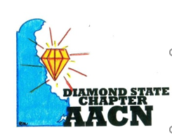
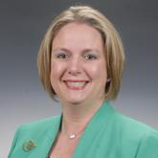
Keynote speaker: Megan E. Brunson, MSN, RN, CNL, CCRN-CSC, FCCM AACN Past President

Registration to begin at 7:30am. Conference ends at 3:30 pm
When: Friday, September 9th, 2022
Where: Virden Retreat and Conference Center in Lewes, DE.
Cost: Students-$30
Members-$50
Non-Members-$65
For information about nursing continuing education, please use the link below:
Contact The Diamond State Chapter of AACN | The Diamond State Chapter of AACN | Nursing Network
Email msmakulski@christianacare.org with questions.

