Poster or Podium Presentation Opportunity

You could be chosen to present at the 2022 Conference presented by the Diamond State Chapter of AACN!

“Moving Forward Together”

Call for abstracts for 30-minute podium or poster presentations. Submissions should pertain to critical care nurses and how they can make an optimal contribution to nurses themselves, patients, and families within Delaware.

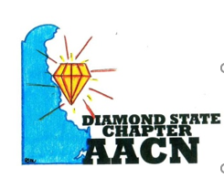

https://forms.gle/DaEDdej4pnm9SSbr8
Deadline for submission is May 1st, 2022
Presenters will be notified by 6/30/22 via email with the status of their submission. Conference is Friday, September 9th, 2022 at the Virden Retreat and Conference Center in Lewes, DE.
*Presenters must be registered for the conference. Email msmakulski@christianacare.org with questions.

