Stained Glass Workshop
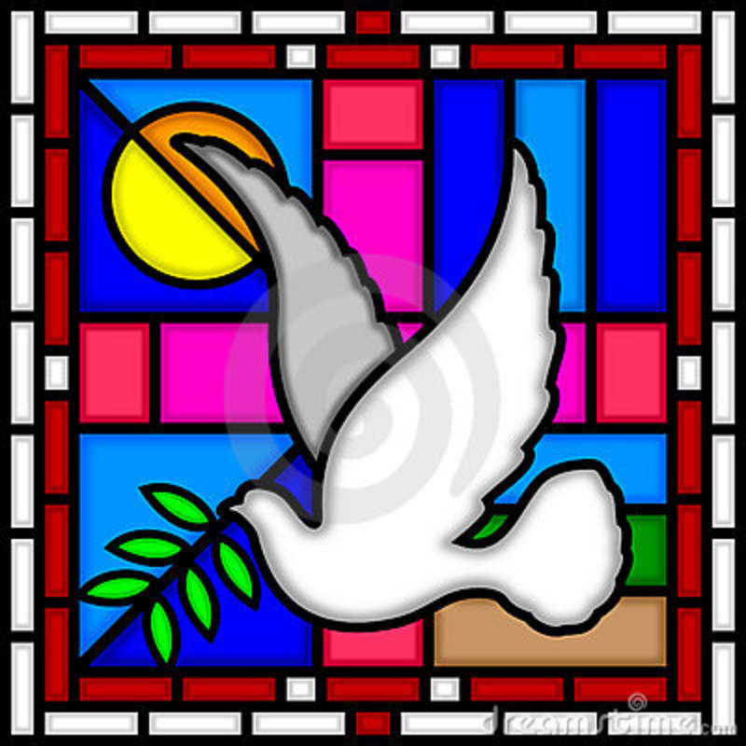
Maryland Glass Creations
7150 E Furnace Branch Road
Glen Burnie, MD

You are Invited to Join Us
Saturday, March 26th at 6:00pm
Fee in Advance $60-$70, depending on project
RSVP to Kimipelegirl@yahoo.com for more info. 