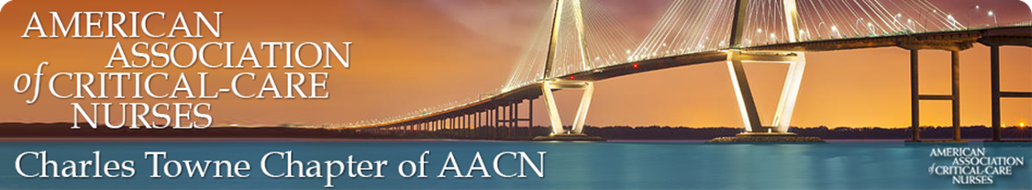

**NTI SCHOLARSHIP FOR CHAPTER MEMBERS**

Our service for this quarter is to invest into one of you! We are offering a NTI scholarship to one of our members for this upcoming NTI in Houston, TX May 16-18th In Person **OR** June 6-8th Virtual.

The scholarship will be for the early bird  member registration for the FULL conference for choice of in person or virtual. **DEADLINE FOR EARY BIRD** **REGISTRATION IS MARCH 31st.**The recipient will be responsible for all other expenses (travel, hotel, food, etc). The recipient will be reimbursed **AFTER** the conference and upon the provision of the confirmation of attendance receipt from AACN.   Given the uncertainties our community still faces, AACN is offering the flexibility of being able to transfer from in-person to virtual or vice versa until May 14, 2022 if the need arises.

If you are interested, the scholarship application is attached and should be submitted no later than**MARCH 14TH to**[**grace.rankin@rsfh.com**](mailto:grace.rankin@rsfh.com)You do not have to complete the meeting attendance section as this will be reviewed from our documented attendance and may not have weighted value for this scholarship due to only recently resuming in person meetings.    For more information about NTI, visit AACN.org , select conferences & events to be directed to NTI.

