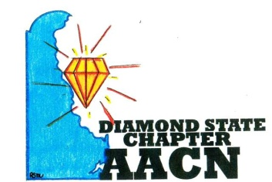
“Shine Bright Like A Diamond”
Agenda-March 8, 2022
- Welcome and Recognition
- Introductions of any new members
- Recognition of newly certified or any other professional accomplishments of chapter members
- Report
- Treasurer report
- Pending Business
- Symposium Updates
- NTI Scholarship
- Cards
- Ukraine
- CAT Updates
- Wellness Check-in
- Roundtable
Next meeting April 12, 2022 via Zoom

