2022 BRIEFING FOR
WEST VIRGINIA LEGISLATORS
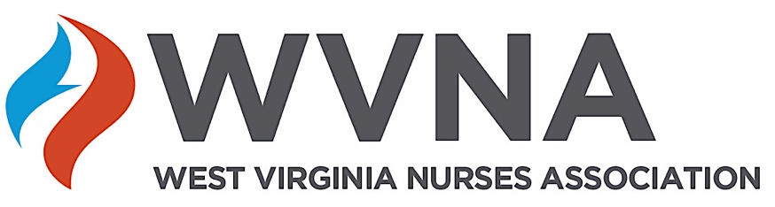

Joyce Wilson, WVNA President
304 613-5508
Joycewilsonfnp@gmail.com

Loarie Butcher, Government Relations Representative
304 543-7174
lhb@lhbstrat.com

Julie Huron, Executive Director
866 WVNurse
centraloffice@wvnurses.org

WVNurses.org

Nurses in West Virginia are a community of over 40,000 nurses. We strive to provide care to West Virginians through science-driven, safe, effective and high quality nursing care. WVNA stands by as a respected nursing community to inform you and your staff about the following issues formed by our experience, expertise and advocacy for patients.

#1 HOUSE BILL 4351 – (Patient Safety and Transparency Act). The purpose of this bill is to ensure that staffing plans are sent to the state health office as well as to the Department of Homeland Security.
- A bill to require establishing a comprehensive acuity-based staffing system creating staffing plans to handle daily workloads as well as during states of emergencies.
- Include nurses on staffing committees.
- Provide orientation to nurses to the clinical area, including temporary assignments prior to sending them to the unit.
- WVNA urges support for HB4351.

#2 HOUSE BILL HB4581 – (Relating to provide safe harbor peer review process for nurses).

- Permits a nurse to refuse an assignment if the nurse believes that the assignment would constitute grounds for reporting the nurse to the board of nursing, constitute a minor incident, or constitute another violation of the nurse practice act or board rules.
- WVNA urges support for HB4581.

#3 HOUSE BILL HB 4111– APRNs: (Prescriptive authority for Advanced Practice Registered Nurses).

- APRN’s have had limitations on prescriptive authority suspended through Governor Justice’s Executive Orders throughout the pandemic. APRN’s have proven themselves to be safe and effective and team players (zero complaints) by proving their ability to prescribe safely and responsibly, while helping care for West Virginian’s.
- WVNA urges support for HB4111.

#4 HOUSE BILL SB271 – CRNA: (Relating to the administration of anesthetics).

- CRNA’s have had administered anesthesia through Governor Justice’s Executive Orders throughout the pandemic. CRNA’s have proven themselves to be safe and effective and team players by proving their ability to practice safely, while helping care for West Virginian’s.
- This bill allows the CRNA and physician or dentist to work together with each area of expertise at their respective level of education.
- WVNA urges support for SB271.
#5 HOUSE BILL HB2345 – School Nurse: (Relating to requiring each county school board to employ at least one full time school nurse for each public school).
- Each county school board should employ at least one full-time school nurse in each school.
- Specialized health procedures that require the skill, knowledge and judgment of a licensed health professional may be performed only by school nurses.
- A school nurse, in collaboration with the student’s provider, may delegate health care procedures to a trained school employee that is monitored or supervised by the school nurse. Note: “specialized health procedures” means, but is not limited to, catheterization, suctioning of tracheostomy, naso-gastric tube feeding or gastrostomy tube feeding.
- WVNA urges support for HB2345.

