Delta Tau-at-Large Chapter

Research and Evidence-Based Practice Conference
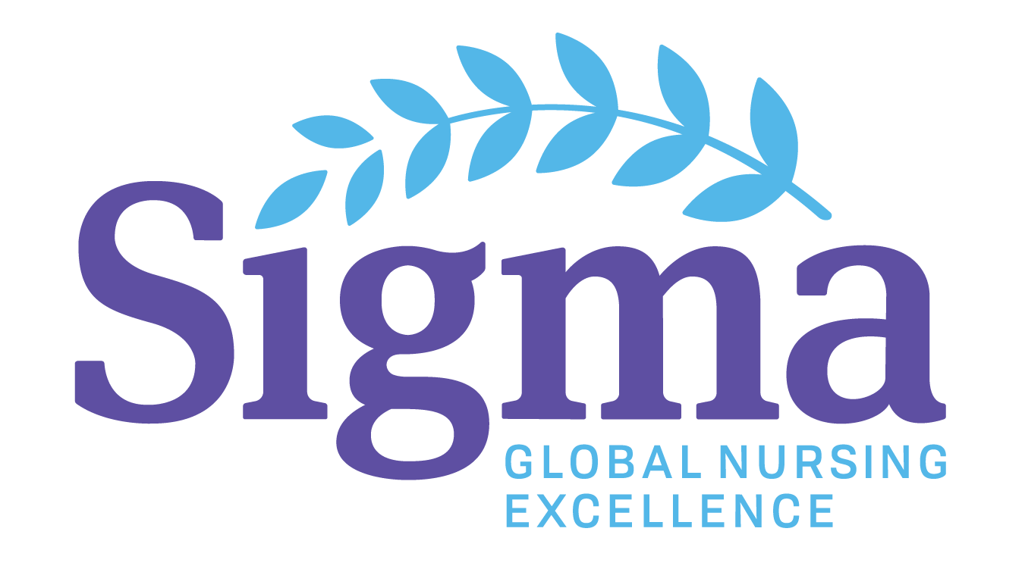

Delta Tau-at-Large Chapter
Eastern University, Holy Family University,
Immaculata University, and Neumann University

Wednesday April 20, 2022
7 pm
A Virtual Event
Program: Live Presenters & Poster Presentations
Cost: Free for Students & Faculty

CALL FOR ABSTRACTS:
Abstracts on research, evidence-based practice, quality improvement and capstone projects accepted. Abstracts due: February 20, 2022
Application https://forms.office.com/r/EQLfbVZfeq
Questions-Contact Ann Zahner - zahnera@neumann.edu
Registration link:
https://www.eventbrite.com/e/delta-tau-at-large-stti-a-virtual-night-of-nursing-practice-and-research-tickets-244470888007

