

Celebrating PANAW 2022!

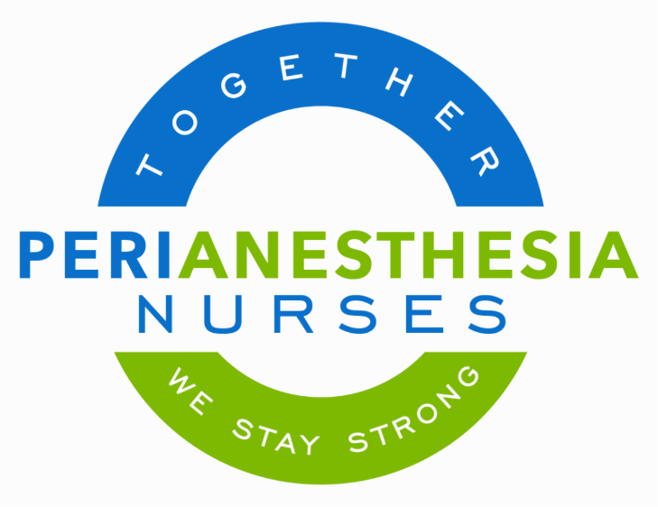



We are stronger together! Importance of Connection, Power of Community!
We salute 60,000 brilliant, skilled, and caring perianesthesia nurses across the United States. What better time to connect with a perianesthesia nurse than PANAW? This is our week, and it is prime time to build up our community, your community!

The community of perianesthesia nurses is found throughout healthcare, from preop clinics to the recovery room, all phases, all ages, and beyond – we are present! A voice of reassurance, a touch that has the power to sooth the soul, and expertise that is second to none – this is the perianesthesia nurse. The safe care you provide patients daily is priceless. Perianesthesia nursing is quite possibly the best kept secret in healthcare. Perianesthesia nursing is so often the wind beneath the wings of many, lifting them up to soar! We teach, we coach, we stand in the gap for our patients! Courage, advocacy, respect, excellence, and service is who we are!

Today, I salute you, the ones who work diligently, often behind the scenes to provide best care and truly make a lasting impact on the lives of humanity. Take pride in who you are and the tremendous gift you bring to your patients every day.

“The more you praise and celebrate your life, the more there is in life to celebrate.”¹ I wish you a glorious PeriAnesthesia Nurse Awareness Week! Share how you celebrate PANAW. Take 2 minutes, snap a photo, and send it to bgodden@aspan.org for inclusion in Breathline, our member newsletter!

Together,

Jenny Kilgore, BSN, RN, CPAN
ASPAN President 2021-22

