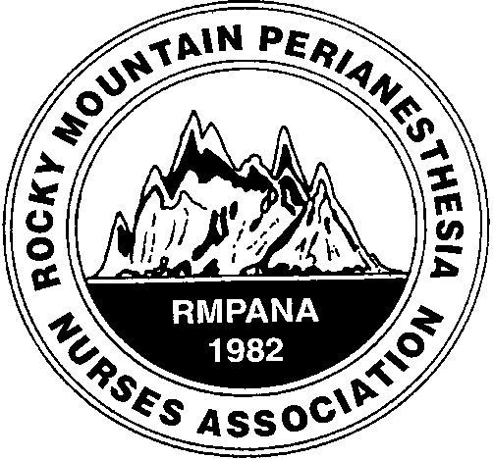

Revitalization of Rocky Mountain
PeriAnesthesia Association

The pandemic has taken its toll even on professional organizations. RMPANA struggled with how to offer the usual educational meetings and conferences.
We are back on track!

Nurses need education, contact hours and a boost to their career ladders and resumes.

Here are a few inspirations and motivations:
- Quarterly meetings:
  - Castle Rock is hosting a Zoom quarterly meeting on Feb. 5, 2022
  - The first 40 to sign up get a Starbucks gift card!
  - Includes Journal club review and Two contact hours
  - See the attached flyer
- Annual Workshop:
  - District 1 is presenting a conference April 30, 2022, at the downtown Hyatt Regency
  - This conference will provide 4 contact hours
  - The lectures will be followed by a happy hour at the rooftop lounge sponsored by RMPANA!
  - Flyer and details coming soon
- Leadership opportunities:
  - It is time to vote in a NEW Board for District 1 (the Denver Metro area)
  - RMPANA has a strong component BOD for support and advise
  - Advantages to volunteering for RMPANA District 1 include
    - The president can attend the ASPAN National Conference with ALL expenses paid
    - Other positions are also rewarded with discounts and advantages.
    - Volunteering for your professional organization carries a lot of clout for career ladders and broadening professional opportunities
    - You can gain ABPANC credit hours for recertification: Involvement in a Professional Organization outside of your hospital gives you 5 contact hours per organization per year.

The opened positions:
- President
- Vice President
- Secretary
- Membership
- Education chair and committee members: a variety of needs/roles, some very simple and others a bit more involved
If you feel intimidated or not quite ready, taking a lesser position and moving up the ladder is a great way to start. Let us know if you are interested, if you know someone who would consider stepping up or if we can answer any questions.

Tina Empey, RN, CPAN, District 1 Membership Chair: tinaempey@gmail.com
Sandy Olson, RN, CAPA, District 1 President: skolson9@yahoo.com

