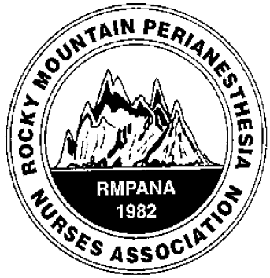**district 1**

quarterly education

meeting

When

February 5, 2022, sponsored by Castle Rock Hospital 0730- JOURNAL CLUB

0800-1015 GUEST SPEAKERS

Where: zoom option only

|  |  |
| --- | --- |
| Meeting URL: | <https://centura.zoom.us/j/97405175863> |
|  | |
| **Toll-free numbers should only be used when long distance charges apply** | |
| Dial: | +1 720 835 1878  877 853 5247 (Toll-Free) +1 778 907 2071  855 703 8985 (Toll-Free) |
| Meeting ID: | 974 0517 5863 |

Guest speaker # 1 Piper Lynn Rudel MSN, FNP-C, Preadmission testing screening at Castle Rock Hospital

Cardiac considerations pre and post Anesthesia

Guest speaker # 2 David Archibald MD, [Otolaryngology-](https://health.usnews.com/doctors/ent-otolaryngologists) specializing in Head & Neck Plastic Surgery

Perioperative management of facial plastic surgery patients

**JOURNAL CLUB ARTICLE:** Journal of PeriAnesthesia Nursing: December 2021COCHRANE CORNER|[VOLUME 36, ISSUE 6](https://www.jopan.org/issue/S1089-9472(20)X0007-4), P730-731, DECEMBER 01, 2021Perioperative Beta-Blockers for Preventing Surgery-Related Mortality and Morbidity in Adults Undergoing Non-Cardiac Surgery. Stephanie Windle, DNP, RN, CNE, Daphne Stannard, PhD, RN, CNS, FCCM       
<https://doi.org/10.1016/j.jopan.2021.08.006>