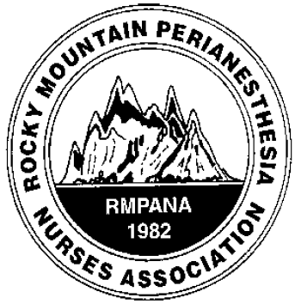
district 1

quarterly education

meeting

When
February 5, 2022, sponsored by Castle Rock Hospital 0730- JOURNAL CLUB
0800-1015 GUEST SPEAKERS

Where: zoom option only
Meeting URL: | https://centura.zoom.us/j/97405175863
Toll-free numbers should only be used when long distance charges apply
Dial: | +1 720 835 1878  877 853 5247 (Toll-Free) +1 778 907 2071  855 703 8985 (Toll-Free)
Meeting ID: | 974 0517 5863
Guest speaker # 1 Piper Lynn Rudel MSN, FNP-C, Preadmission testing screening at Castle Rock Hospital

Cardiac considerations pre and post Anesthesia

Guest speaker # 2 David Archibald MD, Otolaryngology- specializing in Head & Neck Plastic Surgery

Perioperative management of facial plastic surgery patients
JOURNAL CLUB ARTICLE: Journal of PeriAnesthesia Nursing: December 2021COCHRANE CORNER| VOLUME 36, ISSUE 6, P730-731, DECEMBER 01, 2021Perioperative Beta-Blockers for Preventing Surgery-Related Mortality and Morbidity in Adults Undergoing Non-Cardiac Surgery. Stephanie Windle, DNP, RN, CNE, Daphne Stannard, PhD, RN, CNS, FCCM
https://doi.org/10.1016/j.jopan.2021.08.006

