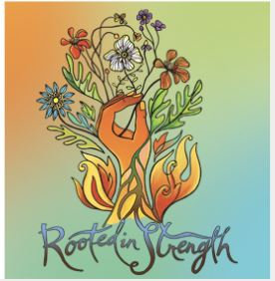

**GFAC-AACN Critical Care Symposium**

**Educational Dinner Event**

**Monday, February 7, 2022**

3:00 – 8:15 p.m.

**Stevenson Ridge**

6901 Meeting Street, Spotsylvania, VA

$40 – Includes dinner and CEU’s

Business meeting to follow – all current and prospective GFAC members are invited!

Sign-up on: gfacaacn.nursingnetwork.com

Please invite your nursing friends and co-workers!

