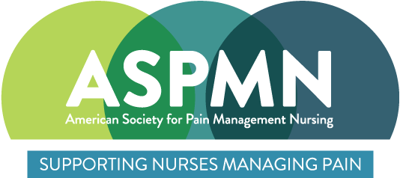
ASPMN- LI POB 405, East Setauket, NY 11733

Meeting Announcement

“Pain 101 for the In-patient Clinician”
Mary Milano Carter MS, NP-BC, PMGT-BC, GERO-BC
Marie O’Brien, DNP, ANP-C, PMGT-BC, CCRN
Jamina John, ACNP-BC, PMGT-BC

Date: November 16, 2021

Time: 7:00 PM

Where: Your Home Via ZOOM (Zoom info to be mailed after registration)
Objectives: 1. Apply the biopsychosocial model of pain to the care of a hospitalized patient.
2. Explain the connection between stress and pain.
3. Create a multimodal treatment plan for a hospitalized patient applying a step-wise approach.

4. Identify symptoms of opioid withdrawal.

5. Understand proper opioid weaning.

6. Describe alternate therapies to assist with opioid withdrawal.

7. Define multimodal pain management.

8. Identify medications used in a multimodal approach in managing pain.

RSVP: To Sandra Kuefner at sh7551@verizon.net by November 12th
Please include your name, license #, address, hospital organization and chapter affiliation in response. Thank you!

The speakers declare they have no actual, potential or perceived vested interests in relation to this program.

Application has been made to the Greater Kansas City Chapter of the American Society for Pain Management Nursing is approved as a provider of continuing nursing education by the Kansas State Board of Nursing. This course offering is approved for 1.5 contact hours applicable for RN, LPN, or LMHT re-licensure and 0.5 pharmaceutical contact hours for APN. Kansas State Board of Nursing Provider Number: GKCC449.
** Note: Registration is required

Planning committee: Sandra Kuefner, ANP and Mary Milano Carter, ANP

