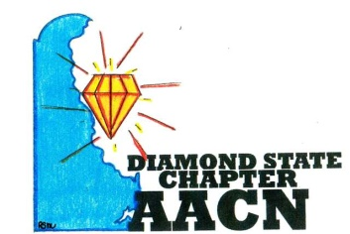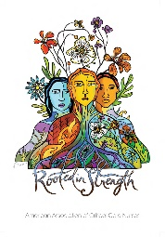
“Shine Bright Like A Diamond”
Agenda-November 9, 2021
- Welcome and Recognition
- Introductions of any new members
- Recognition of newly certified or any other professional accomplishments of chapter members
- Report
- Treasurer report
- Pending Business
- Rooted in Strength- October Member Highlight: Dennise Washington
November Member Highlight: Lisa Markiewicz
- Sub-Groups
**Membership: Membership Drive Planning
**Recognition/Certification: Gift to new members
-New Members will be mailed a welcome gift
**Social Media: Facebook/Instagram re-invigoration
**Education: Conference Details; Planning Meetings
-DNA Updates: Chris Otto
**Volunteer/Outreach: Wilmington Thanksgiving Meal; Operation Shoebox for Christmas
- CAT Updates
- Wellness Check-in
- Roundtable
Next meeting December14,2021 at 6PM TBD

