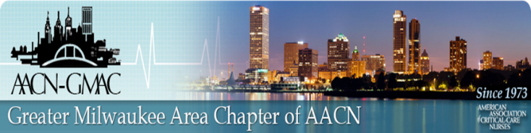

**Virtual Education Session**

**November 11, 2021**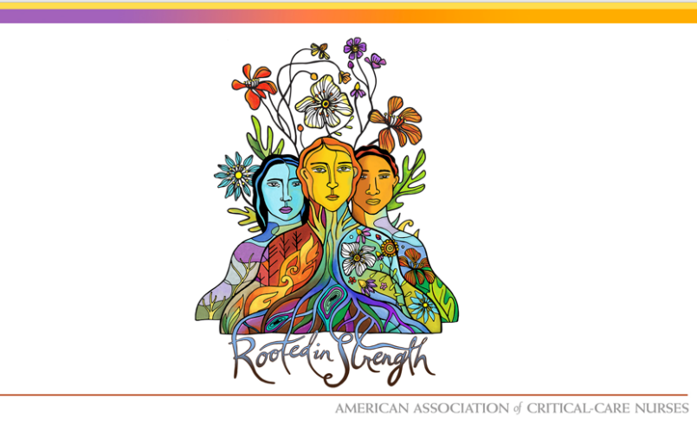

**AACN Theme:**

**“Rooted in Strength”**

by:

Beth Wathen, MSN, RN, CCRN-K

AACN President

Program:

7:30 p.m. AACN-GMAC Welcome and Announcements

7:35 p.m. Presentation

**This is a FREE event. All participants need to register for zoom link:**

<https://us02web.zoom.us/webinar/register/WN_0hdQBq6cTF2zKNlOQZaSKA>

*Link for evaluation and CE will be provided after the session.*

Objectives:

* Define two elements of your personal ecosystem which you consider essential to well-being.
* Reflect on two of your own insights about well-being and how they can inspire you in the workplace.
* Create a plan to balance your own personal ecosystem among self, family, friends, and work.