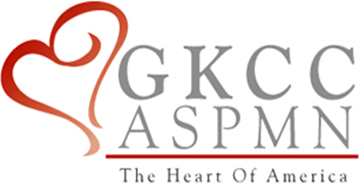

Greater Kansas City Chapter of the American Society for Pain Management Nursing

Presents

**Marilyn E. Stockman, BSN, MBA/MHM**

**Meeting the Regulatory Standards for**

**Pain Management Assessment**

**Monday, April 6, 2015**

**5:30 p.m. – Chapter meeting 6:00 p.m. – Program**

St. Joseph Medical Center, Community Center Conference Room

1000 Carondelet Dr., Kansas City, MO 64114

(Free parking in front of the Community Center building)

Register at

www.gkccaspmn.org

ASPMN Members: Free Non-Members: $10

Objectives:

1. Identify regulatory requirements for pain management assessment and reassessment.
2. Compare and contrast your hospital policy and procedures and care delivery process for pain management with the regulatory standards.
3. Identify the importance of tracer methodology compliance with pain standards.
4. List one example of how you can provide care to impact pain management with your patient.

Greater Kansas City Chapter of the American Society of Pain Management Nursing is approved as a provider of continuing education by the Kansas State Board of Nursing. This course offering is approved for 1.2 contact hours applicable for RN, LPN, or LMHT relicensure. Kansas State Board of Nursing provider number #LT0279-0412GKCC29