EASTERN PIEDMONT ENA PROFESSIONAL NETWORKING EVENT

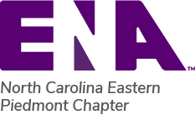

When: Thursday October 21, 6pm-9pm
Where: Camel City BBQ Factory 701 North Liberty St. Winston Salem
Join us for an evening of fun with colleagues and a chance to relax and get rid of that stress! There is food and drinks for purchase and an arcade room. Bring a friend!
RSVP at epena.nursingnetwork.com or email with questions to nepiedmontena@gmail.com

