Paint/Sip Event - Cure the Burn (Out)

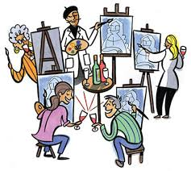 **Muse Paint Bar**

*1915 Town Centre Blvd, #110*

*Annapolis, Maryland*

**Wednesday, October 13th**

**7:00pm – 9:00pm**

*Arrive 6:30pm*

<https://www.musepaintbar.com/events/classic-canvas-148138>

**Please join us, Maryland Nurses Association District 3.**

**RSVP to** [**kimipelegirl@yahoo.com**](mailto:kimipelegirl@yahoo.com) **for more info.**

Fee $35 in advance.

Free appetizers.