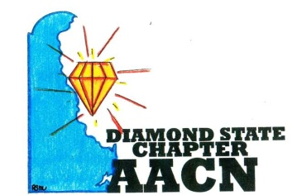

“Shine Bright Like A Diamond”

Fiscal Year 2022 Meetings (All Meetings will begin at 6pm)

September 7, 2021

October 12, 2021

November 9, 2021

December 14, 2021

January 11, 2022

February 8, 2022

March 8, 2022

April 12, 2022

May TBD- Dependent upon NTI being virtual or in person

June 14, 2022