VIRGIN ISLANDS STATE NURSES ASSOCIATION

Give the VISNA Convention a

“THEME with a Difference”



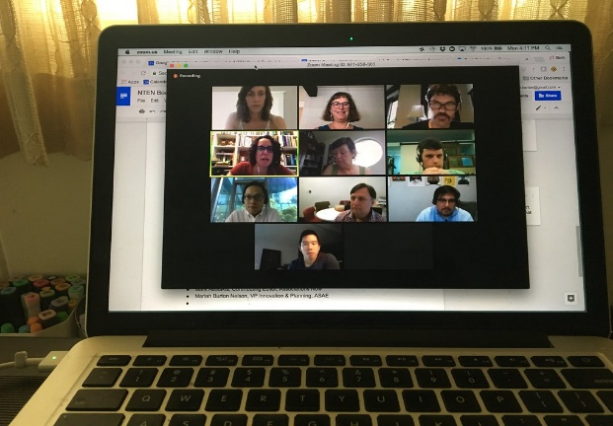

[This Photo](https://www.flickr.com/photos/cambodia4kidsorg/36455183573/in/photostream/) by Unknown Author is licensed under [CC BY](https://creativecommons.org/licenses/by/3.0/)

Your participation is invited in submitting a theme for this year’s biennial convention which is being planned as a hybrid of live and virtual attendance. Given the events of 2020 to date what should this event reflect?

**Please send to visnaus@icloud.com by August 6, 2021.**

Forums on the issues impacting nursing practice will precede the actual Convention on October 9, 2021. Officers and Directors will be elected for another biennium. Look out for the details to follow shortly and plan to attend.