

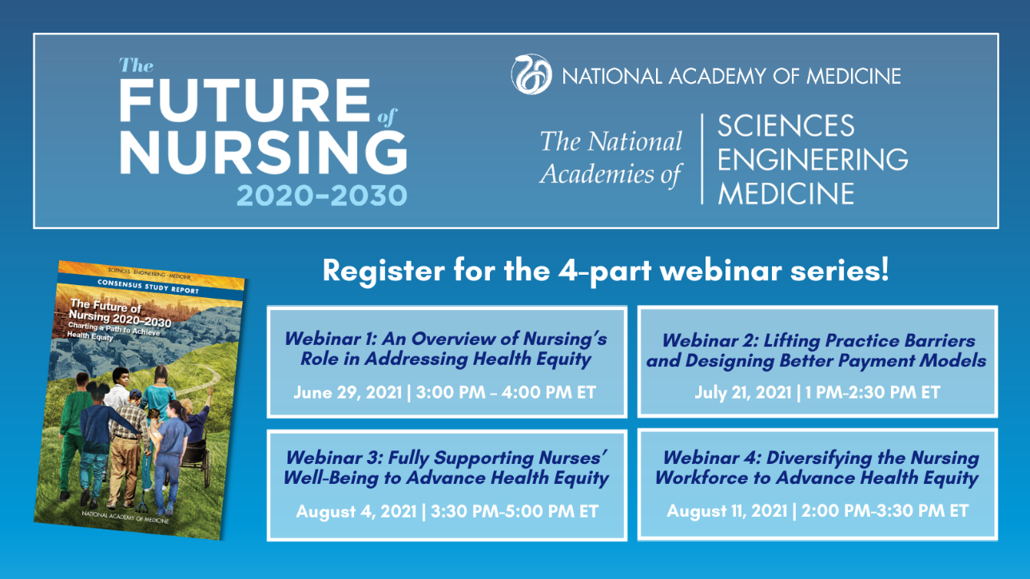

The Future of Nursing 2020-2030
4-Part Webinar Series
Register Today!
June 29, 2021 | 3:00 PM – 4:00 PM ET
July 21, 2021 | 1:00 PM – 2:30 PM ET
August 4, 2021 | 3:30 PM – 5:00 PM ET
August 11, 2021 | 2:00 PM – 3:30 PM ET

The NAM presents a 4-part webinar series that will explore the blueprint for the next decade of nursing as outlined in the consensus report titled Future of Nursing 2020-2030: Charting a Path to Achieve Health Equity, released in May 2021. The series will expand on addressing the roots of racial inequity and strategies nurses can employ to improve health outcomes, lifting barriers to expand nurses’ scope of practice, addressing nurses’ well-being, and diversifying the nursing workforces to address health equity. Register for each webinar discussion below.
Attendees of the discussion series will gain insight into the following learning objectives across the series:
- The roots of health inequities, the social determinants of health, and strategies for the nursing profession to improve health outcomes
- Scope of practice barriers that impact nurses’ ability to address social determinants of health and work toward achieving health equity
- How payment models and mechanisms can be designed to support the nursing workforce in addressing social needs and social determinants of health
- How the nursing workforce can be strengthened and diversified through education, preparedness, and leadership
Webinar 1: An Overview of Nursing’s Role in Addressing Health Equity
June 29, 2021 | 3:00 PM – 4:00 PM ET
Webinar 2: Lifting Practice Barriers and Designing Better Payment Models to Expand the Contributions of Nurses
July 21, 2021 | 1:00 PM – 2:30 PM ET

Webinar 3: Fully Supporting Nurses’ Well-Being to Advance Health Equity
August 4, 2021 | 3:30 PM – 5:00 PM ET
Webinar 4: Diversifying the Nursing Workforce to Advance Health Equity
August 11, 2021 | 2:00 PM – 3:30 PM ET
The National League for Nursing will provide CEUs for this webinar series pending the completion of a short quiz that will be shared after each event.

Register:

Webinar 1: Nurse’s role in addressing health equity

Webinar 2: Lifting barriers to expand the contributions of all nurses

Webinar 3 : Addressing nurses’ well-being

Webinar 4: Diversifying the nursing workforce to advance health equity

Download and share the graphics below!

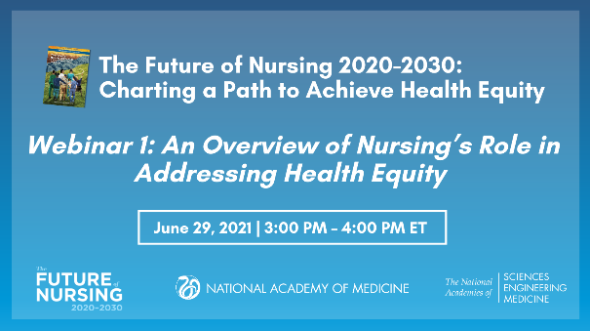
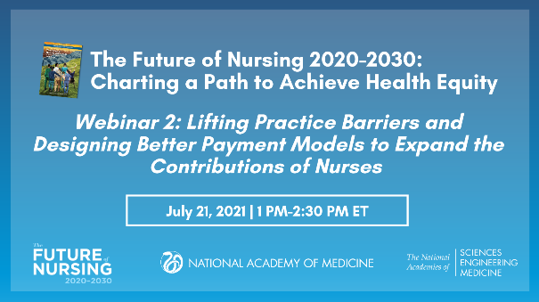

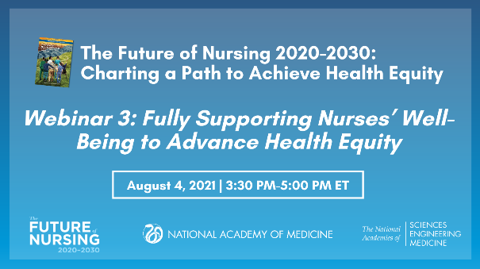
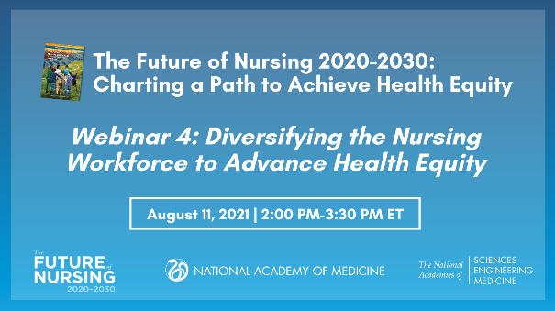

Questions? Contact us at FutureofNursing2030@nas.edu

