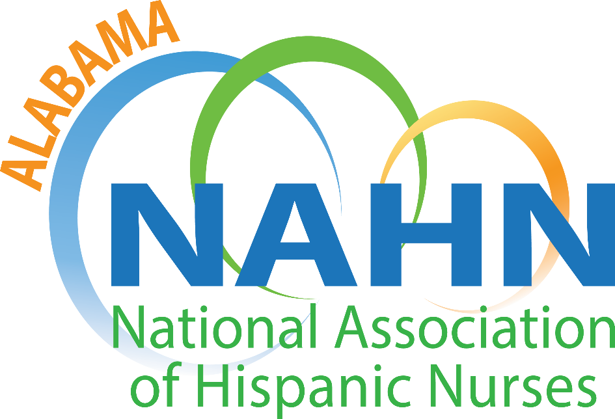

AGENDA
AL-NAHN Chapter Meeting
Thursday, June 10, 2021
7:00 PM – 8:00 PM
Via Zoom

7:00pm-7:10pm
- Call to order Yaricet Matos-Ramos

- Roll call Carlos Guerrero

- Adoption of Agenda Yaricet Matos-Ramos (motion/second)

- Recognition of New Board Members Yaricet Matos-Ramos

- Approval of February 17, 2021 Minutes Yaricet Matos-Ramos (motion/second)

- Treasurer’s Report Grace Grau

7:10pm-7:30pm
- Old Business Executive Board Members

7:30pm-7:50pm
- New Business
  - NAHN President-Elect Candidate Platform Veronica Vital
  - Scholarship Applications Executive Board Members
  - Committee call for leaders
7:50pm-8:00pm
- Announcements Open to all members

- Next Chapter Meeting Yaricet Matos-Ramos

- Adjournment Yaricet Matos-Ramos (motion/second)

