THE CARIBBEAN NURSES ORGANIZATION

Region I
Bahamas
Bermuda
Belize
Cayman Islands
Jamaica
Turks & Caicos

Region II
Anguilla
Aruba
British Virgin Is.
CANA
ODEAN (Netherlands Antilles)
Puerto Rico
S t Croix
St Thomas
St Kitts & Nevis

Region III
Antigua
Dominica
Guadeloupe
Haiti
Martinique
Monsterrat
St Lucia

Region IV
Barbados
French Guiana
Grenada
Guyana
St Vincent and the Grenadines
Suriname
Trinidad and Tobago

Antigua and Barbuda Nurses Association Headquarters
Queen Elizabeth Highway, St Johns, Antigua
Tel: 1(268) 728-2586
E-mail: caribbeannurses@gmail.com * elnora88@hotmail.com
President: Mrs. Elnora Warner Secretary: Mrs. Patsy Edwards Henry
Treasurer: Mrs. Michelle Hales Thompson

FROM THE DESK OF THE PRESIDENT OF THE CARIBBEAN NURSES ORGANIZATION
Dear CNO Colleagues,
Greetings! on this the occasion of the celebration of another International Nurses Day, May 12, 202I.
The protracted impact of the COVID-19 pandemic, has drawn us as nurses into a spiralling vortex of more lockdowns, curfews, state of emergencies, illness, deaths, vaccines, vaccination roll outs, vaccine hesitancy, anti vax, public debates with controversial political mandates and public health policies. I can well imagine how mentally and physically fatigued you all are as a nurse, who continues to be at the front line of this battle. You may very well be crying out for a vacation but can’t get it because of the shortage of nurses. It is within this milieu that I am attempting to wish you a happy International Nurses Day and week, when it probably is anything but one.
We were looking forward to 2021 with some hopes of a reprieve from the pandemic; instead, it seems almost that our hopes have been ‘dash to pieces’. In particular, many of us have witnessed our colleagues, family members and friends succumb to the dreaded infection of the Corona Virus. Our nursing colleagues in St. Vincent and the Grenadines have been hit with a ‘double whammy’ crisis situation with the eruption of their La Soufrere Volcano along with the spring off effects on neighbouring Barbados and St. Lucia (reminds me of our Caribbean saying “when you neighbour house on fire wet yours”. I therefore have to look for that ‘silver lining behind the dark cloud’ that seem to be hovering over us, in order to encourage us during this Nurses Week Celebration, on International Nurses Day.
One ‘silver lining’ that I can think of, is the fact that a Gallup poll in America shows that Nurses have been ranked as the most trusted professionals for 19 consecutive years. The Gallup Poll asked Americans to rate 20-odd professions for their ‘honesty and integrity’. An impressive 85% of respondents ranked the honesty and ethical standards of Nurses as very high or high – a score nearly 20% higher than their runners up and at least 20 points higher than other medical professionals ranked, including doctors, pharmacist and dentists. I believe that this finding can be generalized to other populations, to include the Caribbean, given the metropolitan nature of North American population.
Among the reasons given why nurses ranked highly in the polls, was that “Nurses work closely with the public providing health care while being mindful of people’s privacy rights”. This is something I think that we can ‘smile about’. Yes, Colleagues, it’s undeniable, you are indeed the superstar of Health Care Systems, you are playing the lead role and your fans (I mean your client’s) like you, they trust you, and that is something that does not come easy in the societal environment of today.
So enjoy your day and week in the spotlight, which is meant to specifically illuminate your most important role as a professional nurse, in the provision of Health Care.
God Bless you all
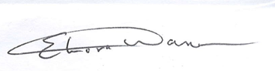
……………………………………………………
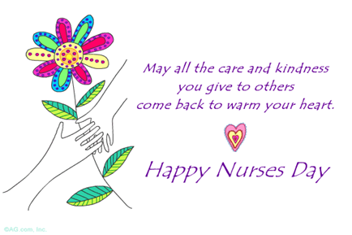
Elnora Warner (Mrs.)
PRESIDENT CNO

