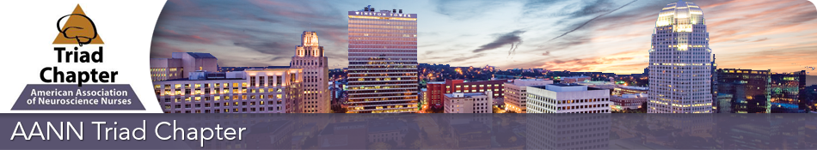
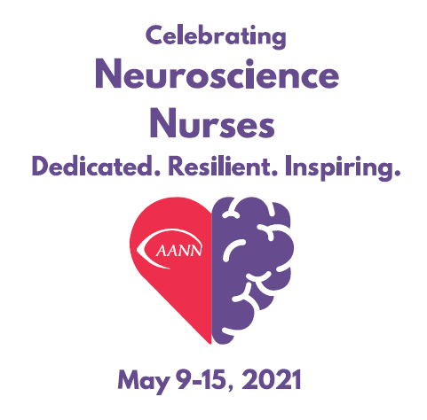
Neuroscience Nurses Week
Over the past year, our lives have been affected in different ways by the COVID-19 pandemic. Now more than ever it's important to celebrate Neuroscience Nurses Week. We appreciate the care you provide your patients, your resiliency, and your dedication to nursing. You are inspiring!
Neuroscience Nurses Week is celebrated during the third week of May each year. During this special week, the North Carolina TRIAD Chapter of AANN would like to pay tribute to all neuroscience nurses.
As a neuroscience nurse, you work hard throughout the year by dedicating yourself to caring for the most vulnerable patients and families. This special week is about recognizing and celebrating YOU and the community of neuroscience nurses.
A special gift will be mailed this week to you from the TRIAD chapter Board. Please contact us at https://triadaann.nursingnetwork.com or email below. Thank you for everything you do!

Sincerely,
President Christine S Roberts csr1995rn@gmail.com csroberts@novanthealth.org
President Elect Denise Rhew Denise.Rhew@conehealth.com
Treasurer Jean Pruitt Jean.Pruitt@conehealth.com
Directors at Large Rayetta Johnson rkjohnsn@wakehealth.edu Gladys Campbell gbcampbe@novanthealth.org
Nominating Committee Chair- Angela Martin amartinrn81@yahoo.com and Gladys Campbell
Education Committee Chair- Sharon Pettiford- spettifo@wakehealth.edu
Social Media Committee Chair-Raylan Melton Adairiusmelton@gmail.com

