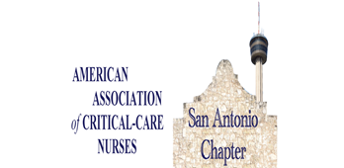  Safe Patient Handling & Mobility: A Better Working Environment for Critical Care  speaker: Patti Mechan PT DPT MPH CSPHP Jan Powers, RN PHd & Michelle Unger-Koop RN BN  MAY 20^{TH,} 2021  7:00-8:30 P.M.  (Central Time)  SAN ANTONIO CHAPTER AACN  Where: Virtual  Join Zoom Meeting:  https://us02web.zoom.us/j/84225792785?pwd=cmFVdkhDWE1vTEFBWkVObDF0d2lHQT09  Meeting ID: 842 2579 2785  Passcode: 330675  One tap mobile  +13126266799,,84225792785#,,,,*330675# US (Chicago)  +19292056099,,84225792785#,,,,*330675# US (New York)  Dial by your location  +1 312 626 6799 US (Chicago)  +1 929 205 6099 US (New York)  +1 301 715 8592 US (Washington DC)  +1 346 248 7799 US (Houston)  +1 669 900 6833 US (San Jose)  +1 253 215 8782 US (Tacoma)  Meeting ID: 842 2579 2785  Passcode: 330675  Find your local number: https://us02web.zoom.us/u/kd4THcUccU Scholarships & Other Chapter Activities)  1 CERP will be awarded | Schedule  7:00-7:15 pm  Chapter Meeting  7:15-8:15 pm  Presentation  8:15-8:30 pm  Q&A/Adjourn  Sponsor:  Guldmann  Register:  sachapteraacn.  Nursingnetwork.com  Objectives:  Discuss Healthcare environment & associated musculoskeletal risk  Discuss Biomechanical and Safety Standards  Recommended Practices & Benefits  Safe Patient Handling & Movement – past and present US  1 CERP awarded.  Dinner provided through a Grub hub Code. Deadline for dinner code is 14th May.
~ Free Program. Send Pictures enjoying Grub Hud Dinner & Program via FB http://www.facebook.com/SAchapterAACN/

