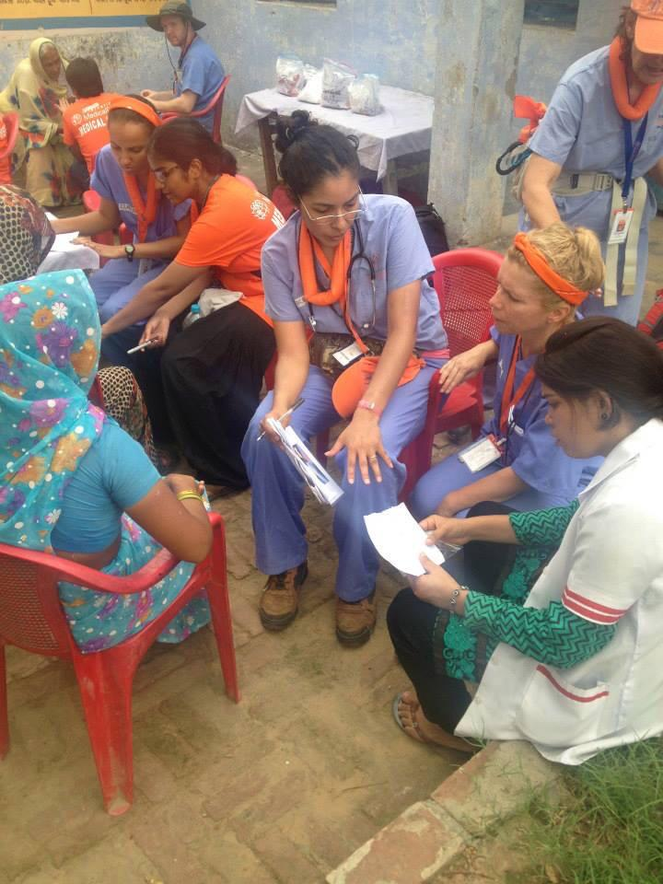
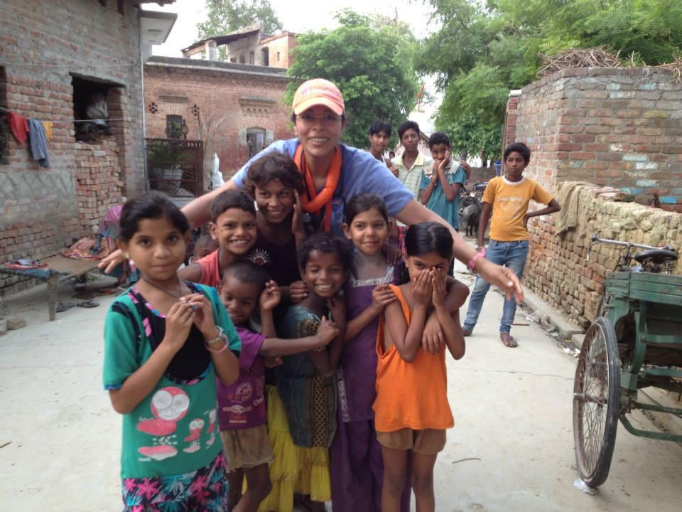
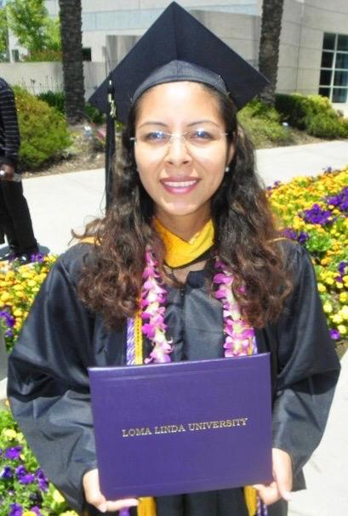
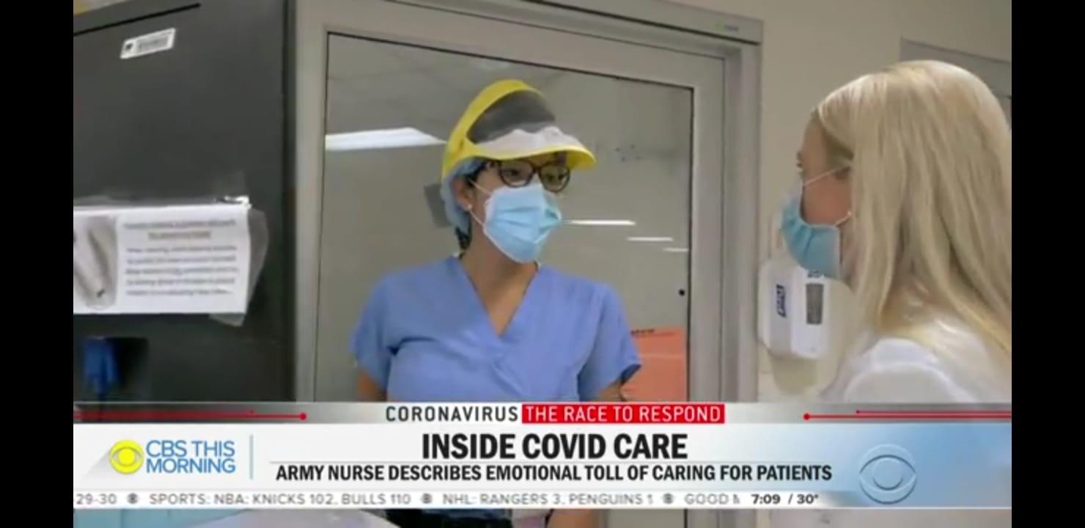
AACN Inland Empire Chapter is so honored to spotlight our members. This month we will be honoring our Chapter President…

AACN Inland Empire Chapter
  - Member Spotlight

Jacqueline Horn

Jacqueline Horn attended nursing school at Loma Linda University - School of Nursing. Her nursing experience is comprised of 10 years. She has devoted herself to working in the following departments: ER, PCU, PACU, and ICU.

She was inspired to become a nurse of because of her love towards medicine. She states,

“The human body is fascinating, and its mechanisms can be intriguing. I think this is one of the reasons I work in critical care. Critical care is humbling. It keeps you centered and allows you to focus not only on physiological processes, but especially on what’s really important...patients. Everything we do in our field revolves around patients. In critical care, our patients remind us every day of how vulnerable we are as human beings and how much we need others to survive in this crazy world. Critical care makes you grateful for every person in your life and for every breath you take. Being a critical care nurse is the most rewarding and self-fulfilling experience I have had.”

Jacqueline has been an AACN member for approximately 5 years, and a chapter member for 3 years. She is the current president of the Inland Empire Chapter. Her role consists of presiding all chapter meetings, providing leadership on guiding chapter business, and ensuring our chapter officers remain engaged. As president, it is her responsibility to ensure our chapter works to meet the educational needs of our Inland Empire Chapter members.

Jacqueline describes how being an AACN member has impacted her professional and personal growth by the following statement:

“Being an AACN member, and specifically a chapter member, has been instrumental for my professional growth. I feel I had always been looking for a big opportunity to grow my leadership skills but had not really gotten one until I became part of this chapter. This chapter has helped me grow tremendously in a professional and personal way. As a professional, I feel my experience with the chapter has grown my confidence to pursue my goals. I’ve proven to myself what I’m capable of when I commit to something. At a personal level, the chapter has helped me realize the importance of taking risks and having faith in yourself.”

Jacqueline believes, “The biggest challenge in the nursing profession today is nurse turnover. High nurse turnover leads to inadequate staffing, which can lead to unhealthy work environments. I think each organization should have a team dedicated to exploring its causes for nurse turnover, for organizational environments are highly influential on this problem. It is important to consider nurses do not simply gravitate towards the money. Healthcare institutions with competitive wages might have a lack of advancement opportunities or unhealthy work environments as the cause for high nurse turnover. Research studies aim to find the most common causes of turnover, but this does not mean these causes will be equally applicable to all institutions. It is important to look at research for a general overview, but each organization should consider dedicating a small part of its budget towards investigating specific institutional reasons for its turnover rates.”

Her advice to new and veteran nurses is:

Read nursing content at least five minutes every day. Our field is evolving, and we must keep up with new developments.

Remember to always try to go the extra mile for your patients. Be the nurse you would like to have care for you someday.

Work to eliminate the “nurses eat their young” mentality. The now “young” nurses might someday care for you or your family. Treat them the way you want to be treated and, most importantly, train them well. You might be training them to care for you or your loved ones in the future.

Be the best nurse you can be. Everything you do as a nurse is a reflection of nurses in our field. When you care for patients, present during rounds, or get involved in different organizations you are representing all of us.

Jaqueline, it is such an honor to spotlight someone as amazing as you! Thank you for your service to nursing and the patients you care for, mentoring students, medical missions and your tireless commitment to the AACN Inland Empire Chapter. We are so incredibly lucky to have you not only as a member but also in our leadership!

