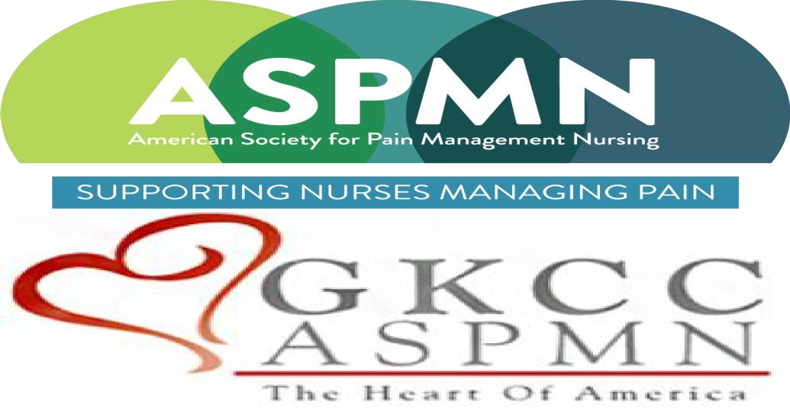  “Pain Management in the Hospice Population: Going Beyond Roxanol”-virtual event  Presented by Angela Interiano, MSN, APRN, AGNP-C, PMGT-BC  Objectives:  - Understand the multidimensional features of pain assessment.  - Name two psychological effects of uncontrolled pain.  - Identify appropriate procedures for pain in the palliative care/hospice population.  - Discuss multimodal approach for pain at end of life.  Greater Kansas City Chapter of the American Society for Pain Management Nursing is approved as a provider of continuing nursing education by the Kansas State Board of Nursing. This course offering is approved for 1.2 contact hours and 0.5 pharmacology contact hours applicable for RN, LPN, or LMHT relicensure. Kansas State Board of Nursing provider number #LT0279-0412GKCC—433. | May 26, 2021  6:00 p.m.  Free 1.2 CNE with 0.5 Pharm CNE.  Registration for:  LPNs, RNs, APRNs  LOCATION:  Once you register on our website you will be sent a link for zoom meeting.  Sponsored by The Greater Kansas City Chapter of the American Society for Pain Management Nursing

