‘Statins & PPIs & H2RAs, Oh my!’
‘Statins, Proton Pump Inhibitors & Histamine-2 Receptor Antagonist, Oh my!’

Melanie R. Symoniak, Pharm.D., BCPS
and
Steven Luc , Pharm.D. Candidate

Sponsored by NACNS-WNY chapter
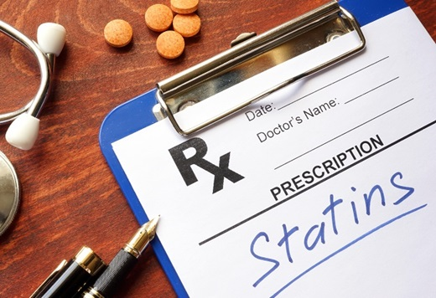

Join us for our virtual April meeting!
Wednesday, April 14th
Via Zoom, Link to follow
RSVP with your email address to Eileen Wilbert: ewilbert@sjfc.edu

4:45pm-5pm: Business meeting
5pm-6pm: Presentation
6pm-6:15pm: Electronic Evaluation

Pending 1 pharm contact hour will be granted.

