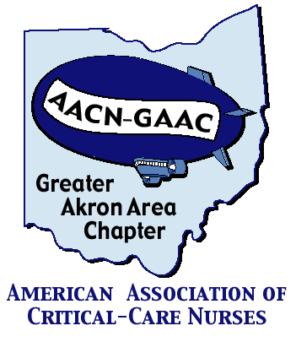
GREATER AKRON AREA Chapter of
AACN
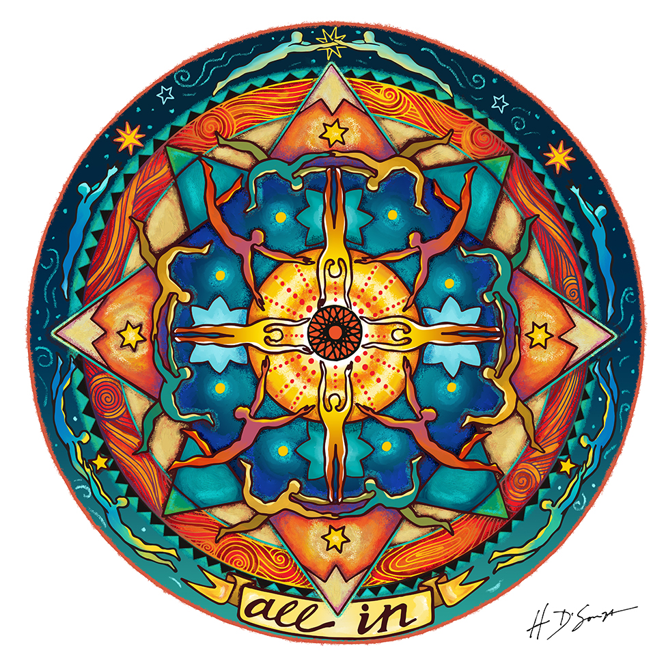

March Program: “COVID-19: One Year Later”

Presenters:
Dr. Pravin George and Beth Shrock, RN

Location: Zoom Meeting
https://us02web.zoom.us/j/2764743924?pwd=UGlDQ1Q5STRZMlA2YjBnS29vaUxGUT09

Meeting ID: 276 474 3924
Passcode: 1900

When: Tuesday, March 9th, 2021

6:00 – 7:30pm

Sponsor: Hatchmed – Bradley Hickey

AGENDA for March 9th, 2021

6:00 – 6:05pm Welcome and Introductions
6:05 – 6:15pm Sponsor presentation
6:15 – 7:15pm Program presentation
7:15 – 7:30 Conclusion/Questions
**7:30 – 8:00 Board Meeting

Objectives:
- Describe the early response to the pandemic
- Identify lessons learned
- Discuss the ongoing response to COVID- 19 in the ICU

Register by: Monday, March 8th, 2021

Please register online @ www.aacngaac.nursingnetwork.com

LIASONS:

CC Akron General: Jennifer Kraus, Cara Meckler,
Stephanie Clubbs, Teresa Westerhiede-Haller
Aultman: Deb Young
Cleveland Clinic: Ellen Prewitt
Medina: Jane Lackey
Metro: Donna Guyette
Summa: Laura Wyrock
University of Akron: Connie Chronister, Laura Wyrock
Western Reserve Hospital: Aimee Weaver
Wooster Community Hospital: Carrie Boss
Akron Children’s Hospital: Melanie Brewster

ABOUT GAAC:

The Greater Akron Area Chapter (GAAC) is a three-time award-winning local chapter of the American Association of Critical-Care Nurses, established in October 2001. We have members from many of the local hospitals and universities.
Meetings are held every other month (except during summer) and are normally preceded by an educational program and dinner. Currently we are holding meetings via Zoom to facilitate social distancing in respond to COVID-19.

Membership:
- $35/year (includes all programs/dinners)
- National AACN membership is REQUIRED
- For in-person meetings: Non GAAC nurses can attend a meeting/dinner for $15 each (students $10)

Membership forms for both the local chapter and national AACN are available on the website

For more information on joining the local chapter, please go to our web site: www.aacngaac.nursingnetwork.com

If you are interested in being a liaison for your unit, hospital or facility, please contact any chapter officer or board member.

GAAC would like to thank our sponsors for their support of this program. There is no endorsement by ANCC, OBN or ONA. commercial products displayed.

