**Virtual Education Event for GI Nurses and Techs**

**Thursday, February 25th**

**7:00 PM Start Time**



**Featuring:**

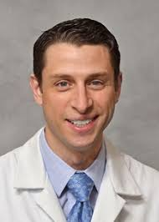

Stuart K Amateau MD PhD FASGE FACG AGAF

Associate Professor of Medicine, Surgery and Pediatrics

Director of Endoscopy

Division of Gastroenterology and Hepatology Clinical Director

GI Medical Director, Medical Subspecialty Service Line

**Program Description**

**Topics:**

Cholangioscopy

&

Therapeutic Colonic Tissue Resection

**CNE Credit**: 2 Free CNE Credits Provided

**Criteria for successful completion**: Attend 100% of virtual event via Zoom

**Registration**

Email and facility required for registration. Please reach out to your Boston Scientific rep below:

**Ben Croatt**

[**croattb@bsci.com**](mailto:croattb@bsci.com)

**952.210.6430**

Zoom link provided after registration

Dr. Amateau is an Associate Professor of Medicine, Gastroenterology, Hepatology and Nutrition at the University of Minnesota. He will join the call to discuss his experience with Cholangioscopy, specifically, when he uses SpyGlass DS and best practice sharing to ensure a successful procedure.