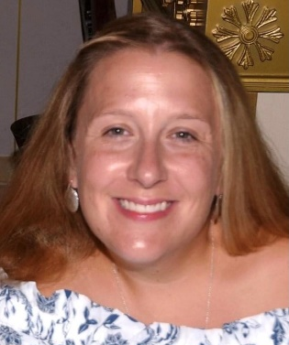
“I’m All In”
Growing up, I always had the best role models. Those role models were my mother, two grandmothers, and a great grandmother and they would do anything for anyone regardless of if it was their family, friend, or a stranger. They were hardworking, caring, and empathetic, amongst so many other great traits. As a young child, I always knew I wanted to be in the medical field. I wanted to be like my role models whom I had always idolized. No, they weren’t in the medical field, but I wanted to embody their traits and values they instilled in me the best way I knew how; by helping.
Over the years, my patients and family have always said, “It takes a special person to do what you do.” I am very grateful to have the experiences that I have had and being able to experience those relationships with my patients and their families. I look at the profession of Nursing as one of the most rewarding, versatile, and challenging careers one can choose. To me, it’s a privilege to help my patients at a time when they are the most vulnerable. The level of trust instilled in a nurse is something I will always appreciate, and it pushes me to continue to advocate for what is necessary. As a nurse, you can practice in so many ways. Long gone are the days when nurses only worked in hospitals. Now, nurses are making their mark in politics, working in research, and education, to name a few. Nurses are diverse and specialized, all while continuing to follow the Nursing Code of Ethics they promised to uphold.
In honor of the 200th anniversary of Florence Nightingale’s birth, the World Health Organization deemed 2020 as the Year of the Nurse and Midwife. No one could have predicted how challenging the year 2020 would be, but nurses continue to show up and help those who need it. These hardworking, caring, and empathetic professionals, whom I am proud to call friends and colleagues, continue to push forward despite many obstacles. These nurses inspire me just as my role models did while growing up. I can only hope that through my work and by helping all who need it, I can be that role model for my children as those were before me. This is why I am ”All In.”

