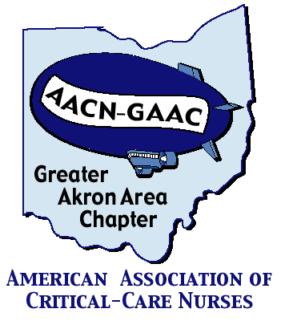
GREATER AKRON AREA Chapter of
AACN


Location: Zoom Meeting
https://us02web.zoom.us/j/2764743924
Meeting ID: 276 474 3924

Program: “MOVE IT!” Early Mobility in the PICU

When: Tuesday, January 12th, 2021
6:00 – 7:30pm

Sponsor: Stryker – Early mobility options

Presenter:
Tammy Camelli DNP, CNP AC-PC

AGENDA for January 12th, 2021

6:00-6:10 pm Welcome and Introductions
6:10 – 6:20 Sponsor presentation
6:20-7:15 pm Program presentation
7:15 – 7:30 Conclusion/Questions
**7:30 – 8:00 Board Meeting

Objectives:
- Describe negative impact of immobility
- Benefits of early mobility
- Early mobility is safe and feasible in critically ill children

Register by: Monday, January 11th, 2021

Please register online @ www.aacngaac.nursingnetwork.com

LIASONS:

CC Akron General: Jennifer Kraus, Cara Meckler,
Stephanie Clubbs, Teresa Westerhiede-Haller
Aultman: Deb Young
Cleveland Clinic: Ellen Prewitt
Medina: Jane Lackey
Metro: Donna Guyette
Summa: Laura Wyrock
University of Akron: Connie Chronister, Laura Wyrock
Western Reserve Hospital: Aimee Weaver
Wooster Community Hospital: Carrie Boss
Akron Children’s Hospital: Melanie Brewster

ABOUT GAAC:

The Greater Akron Area Chapter (GAAC) is a three-time award-winning local chapter of the American Association of Critical-Care Nurses, established in October 2001. We have members from many of the local hospitals and universities.
Meetings are held every other month (except during summer) and are normally preceded by an educational program and dinner. Currently we are holding meetings via Zoom to facilitate social distancing in respond to COVID-19.

Membership:
- $35/year (includes all programs/dinners)
- National AACN membership is REQUIRED
- Non GAAC nurses can attend a meeting/dinner for $15
each (students $10)

Membership forms for both the local chapter and national AACN are available on the website

For more information on joining the local chapter, please go to our web site: www.aacngaac.nursingnetwork.com

If you are interested in being a liaison for your unit, hospital or facility, please contact any chapter officer or board member.

Service Project:
St. Damien Foundation
Each year, GAAC supports a community service agency or group. This year’s agency is the St. Damian Foundation, a group dedicated to bringing the children of Haiti to the US for critical surgery.
Raffles are planned for future meetings

GAAC would like to thank our sponsors for their support of this program. There is no endorsement by ANCC, OBN or ONA. commercial products displayed.

