Virtual Education Event for GI Nurses and Techs
Monday, December 14th
7:00 PM Start Time
Presenter
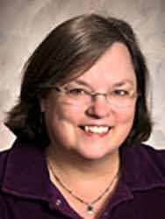
Dr. Grace Thornhill Ph.D. Microbiology
Infection Prevention, Fellow
Program Description

“Tides are Turning: What is your Infection Prevention Strategy for the GI Suite?”

CNE Credit: 1 Free CNE Credit Provided

Criteria for successful completion: Attend 100% of virtual event via Zoom
Registration
Email and facility required for registration. Please reach out to your Boston Scientific rep below:

Ben Croatt
croattb@bsci.com
952.210.6430

Zoom link provided after registration
Dr. Grace Thornhill will lead this CNE discussion on the latest information on enhanced endoscope reprocessing approaches and the impact on contamination rates. Additionally, the current epidemiology of endoscope-associated infections and related clinical data will be reviewed and discussed.

