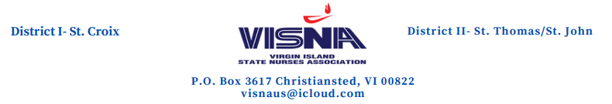

November 16, 2020

Dear Dr. Nunez-Smith,

Congratulations on your appointment as one of the co-chairs of the Biden/Harris Covid-19 task force.

The Virgin Islands State Nurses Association (VISNA) is proud to support one of our Virgin Islanders as part of the medical and scientific team who will be working on controlling the spread of the pandemic and health crisis that the world is facing .VISNA, as a member of the American Nurses Association (ANA) is reaching out to you for your considered influence in having a Registered Professional Nurse(s) selected to work on the main task force or on a subcommittee. VISNA supports the petition of the ANA on this matter.

Nurses are the frontline workers in this pandemic and it’s our belief that we should be represented in some capacity to bring awareness of what nurses face on a daily basis, both personally and professionally, along with other mental health issues. Working during this crisis with limited PPE and other critical supplies, decrease staffing and long hours without breaks is also challenging. Often times nurses are the only ones at the patient’s bedside at their time of transition.

Nurses in some states are members of their local Covid-19 task force. The Health Commissioner, Ms. Justa Encarnacion RN BSN, MBA-HCM is the lead of the COVID-19 task force in the Virgin Islands. VISNA continues to support the mandates of the CDC and local task force.

VISNA wishes you and the members of the task force and the Biden/Harris administration well in this fight. Your leadership in this critical issue is greatly appreciated. VISNA is looking forward to having nurses lend a voice and be an essential part of this health crisis. We truly thank you for all you do.

Respectfully,
Evet Rivera RN President,
Virgin Island State Nurses Association

Cc: Ernest Grant PhD RN FAAN
ANA President



