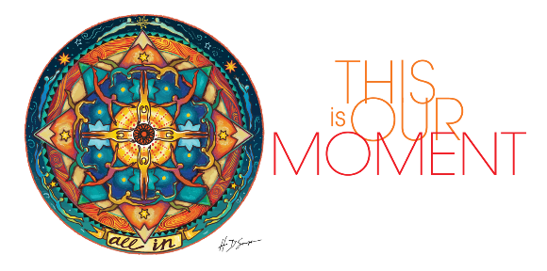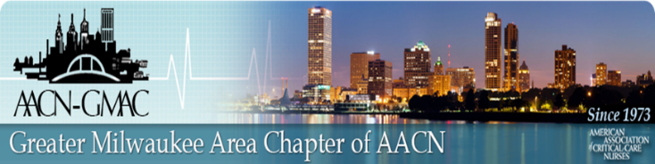

**You Are Invited!**

Virtual Education Session

**November 17, 2020**

**AACN THeme 2020-2021**

**this is our moment – all in!**

Elizabeth Bridges, PhD RN CCNS FCCM, FAAN

AACN President

Pre-register for this webinar: <https://us02web.zoom.us/webinar/register/WN_qphHjDQ9Q5ekXWTlUuEhfw>

Program:

7:15-7:30 p.m. AACN-GMAC Welcome and Announcements

7:30-8:30 p.m. Presentation

**Link to join ZOOM meeting will be sent to pre-registered participants**

Link for evaluation and CE provided after the session.

Objectives:

* Explore the sources of inspiration for the AACN theme This Is Our Moment – and its application to our current reality.
* Discuss strategies to integrate the Stockbridge Paradox (reality and hope) and wise hope in moving towards a hopeful future.
* Discuss the theme and theme art with implications for being “All In”.
* Review AACNs current and upcoming initiatives in response to COVID-19 pandemic.

**Prerequisite to joining Zoom meeting:**

* Zoom Desktop Client or Mobile App (free)
* **After pre-registering on GMAC website**, you will receive an email with link to join meeting; both video and dial in (audio) information.