GREATER AKRON AREA Chapter of
AACN
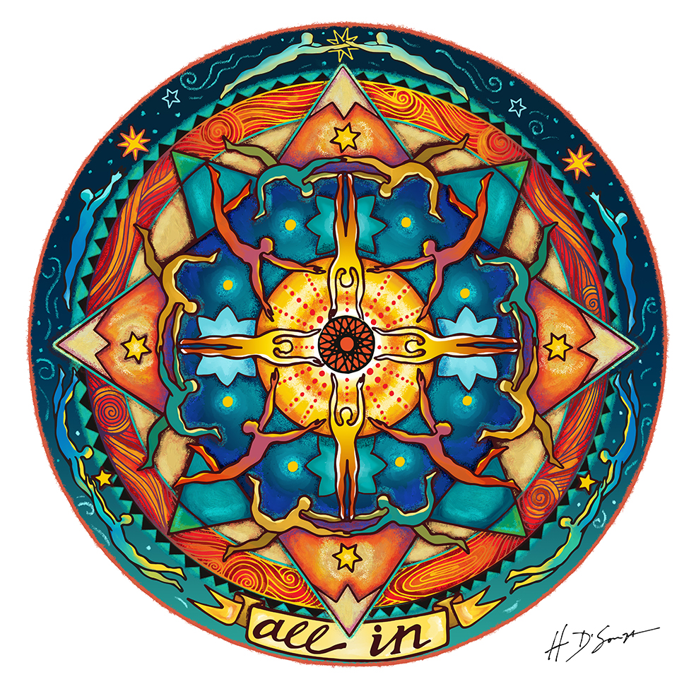

Program: Ventricular Tachycardia Post Myocardial Infarction

When: Tuesday, November 10th, 2020
6:00 – 7:30pm

Location: Zoom meeting – register for login information

Sponsor: Smith-Nephew

Speaker: Nicholas J. Panno III PharmD, BCPS

AGENDA for November 10th, 2020

6:00-6:10 pm Welcome and Introductions

6:10 – 6:20 Sponsor product review: Leaf Patient Monitoring System

6:20 – 7:15 Presentation

7:15 – 7:30 pm Questions?

Objectives:
- Review Physiology of the Cardiac Conduction System
- Describe Pathophysiology of Reentry Ventricular Tachycardia
- Analyze Different Therapies for Benefit/Risk

Register by: Monday, November 9th, 2020

Please register online @ www.aacngaac.nursingnetwork.com
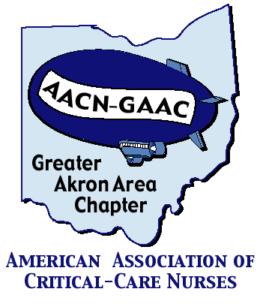

LIASONS:

CC Akron General: Jennifer Kraus, Cara Meckler,
Stephanie Clubbs, Teresa Westerhiede-Haller
Aultman: Deb Young
Cleveland Clinic: Ellen Prewitt
Medina: Jane Lackey
Metro: Donna Guyette
Summa: Laura Wyrock
University of Akron: Connie Chronister, Laura Wyrock

Western Reserve Hospital: Aimee Weaver
Wooster Community Hospital: Carrie Boss and Karen Steiner

ABOUT GAAC:

The Greater Akron Area Chapter (GAAC) is a three-time award-winning local chapter of the American Association of Critical-Care Nurses, established in October 2001. We have members from many of the local hospitals and universities.
Meetings are held every other month (except during summer) and are normally preceded by an educational program and dinner. Currently we are holding meetings via WebEx to facilitate social distancing in respond to COVID-19.

Membership:
- $35/year (includes all programs/dinners)
- National AACN membership is REQUIRED
- Non GAAC nurses can attend a meeting/dinner for $15
each (students $10)

Membership forms for both the local chapter and national AACN are available on the website. You may join at a

meeting/program – the $35 local membership fee will cover your evening as well as your annual dues.

For more information on joining the local chapter, please go to our web site: www.aacngaac.nursingnetwork.com

If you are interested in being a liaison for your unit, hospital or facility, please contact any chapter officer or board member.

Service Project:
St. Damien Foundation
Each year, GAAC supports a community service agency or group. This year’s agency is the St. Damian Foundation, a group dedicated to bringing the children of Haiti to the US for critical surgery.
Raffles are planned for future meetings

GAAC would like to thank our sponsors for their support of this program. There is no endorsement by ANCC, OBN or ONA. commercial products displayed.

