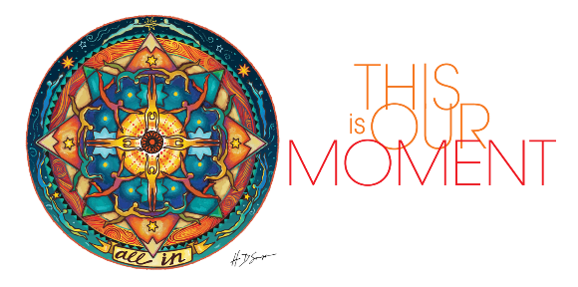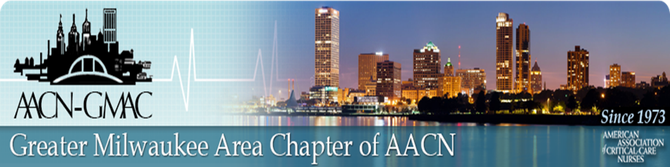

Virtual Education Session

October 20, 2020

**Building Resilient Teams**

Paula Davis-Laack, JD, MAPP

Founder/CEO of Stress & Resilience Institute

Program:

7:15-7:30 p.m. AACN-GMAC Welcome and Announcements

7:30-8:30 p.m. Presentation

**Link to join ZOOM meeting will be sent to pre-registered participants**

Link for evaluation and CE provided after the session.

Objectives:

* Understand why burnout is a systemic issue that requires systemic solutions to effectively address
* Why teams are best suited to help organizations effectively address the burnout problem
* Learn the specific building blocks of resilient, high-performing and thriving teams
* Practice 2-4 specific skills meant to help nurses and their teams effectively address burnout

**Prerequisite to joining Zoom meeting:**

* Zoom Desktop Client or Mobile App (free)
* **After pre-registering on GMAC website**, you will receive an email with link to join meeting (both video and dial in information)