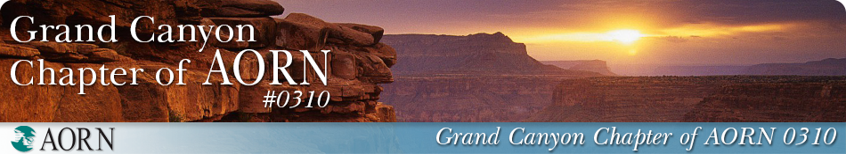

AORN Membership Renewal Scholarship Application

To qualify for this Membership Renewal Scholarship, please provide membership number for the AORN Grand Canyon Chapter. Please provide evidence of attendance of (2) chapter meetings in the last year (example, CE certification of meeting presentation).

Applicant Requirements:

NAME: DATE:

MEMBER ID:

ADDRESS:

EMAIL ADDRESS:

EMPLOYER:

POSITION:

CHAPTER ACTIVITIES:

OFFICES HELD:

C0MMITTEES- CHAIR/MEMBER:

NUMBER OF MEETINGS ATTENDED IN THE PAST YEAR:

On a separate word or PDF document, please answer the following questions:

* In a statement of 150 words, describe how the COVID pandemic has impacted you.

Applications must be submitted by December 5th, 2020.

The Nominating Committee of the Grand Canyon Chapter of AORN will review all completed applications. The scholarship will be announced via Nursing Network and presented to the selected recipient(s) during the subsequent AORN business meeting**.** Those not selected will be notified by email.

Email completed application with accompanying Word or PDF attachments to: [aorngrandcanyon@gmail.com](mailto:aorngrandcanyon@gmail.com)