****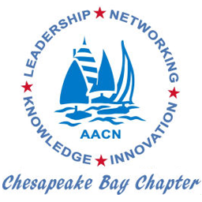**Chesapeake Bay Chapter**

**American Association of Critical Care Nurses presents our first meeting of FY21.**

**Kick Off Meeting:**

**Expectations for Implementing Medication Titration Orders**

Recorded presentation by Robert Campbell, PharmD (Director of Clinical Standards Interpretation Hospital/Ambulatory Program THE Joint Commission) and Connie Barden MSN, RN, CCRN-K, FAAN (Chief Clinical Officer, AACN)

**Thursday October 15, 2020 7:00 PM-8:30 PM**

**GoToMeeting (virtual meeting) – Invite is posted on the website**

Description: Caring for critically ill patients often requires nurses to use titrated medications but understanding and implementing current order requirements can create confusion for the clinician and risk for the patient. For several months, AACN has been working with The Joint Commission to clarify its medication management standard, which delineates required hospital policies for medication orders, including titrated medications. AACN leaders have developed a strong, collaborative relationship with The Joint Commission and were at the forefront of providing input regarding interpretation of its medication management standard. The Joint Commission has now revised its requirements to provide leeway to clinicians and to clarify administration and documentation of titrated medications, along with minimum elements of a complete medication order.

Standard will be in place January 2021.

**Please join us for this education meeting.**

**Registration is FREE for all Chapter Members and Non-Members (use Website to Register)**

**This continuing nursing education activity will offer Certificate of Attendance**

**by the American Association of Critical Care Nurses.**

To Register visit our website: <https://aacncbc.nursingnetwork.com> or use this QR Code.

