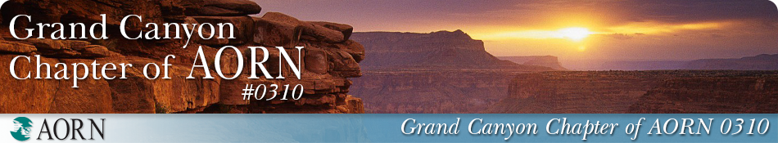

CNOR Scholarship Application

To qualify for this CNOR Scholarship, please verify active participation in AORN Grand Canyon Chapter, in the past year. This scholarship award is $395.00 for: 1st time exam and recertifying exam applicants who pass; or $350.00 for applicants recertifying via points or contact hours. Please attach payment receipt for certification, as well as, passing result or proof of recertification.

Applicant Requirements:

NAME: DATE:

ADDRESS:

EMAIL ADDRESS:

EMPLOYER:

POSITION:

CHAPTER ACTIVITIES:

OFFICES HELD:

C0MMITTEES- CHAIR/MEMBER:

NUMBER OF MEETINGS ATTENDED IN THE PAST YEAR:

On a separate word or PDF document, please answer the following questions:

* If you attended fewer than six chapter meetings, please explain.
* In a statement of 100 words or less, express your goals for becoming a CNOR:
* In 100 words or less, please describe the value of certification.

The Scholarship Committee of the Grand Canyon Chapter of AORN will review all completed applications on a rolling basis. The scholarship will be announced via Nursing Network and presented to the selected recipient(s) during the subsequent AORN business meeting**.** Those not selected will be notified by email.

Email completed application with accompanying Word or PDF attachments to: [aorngrandcanyon@gmail.com](mailto:aorngrandcanyon@gmail.com)