ANPD-H needs you……



To update your mailing address!

Please take a moment to update your mailing address in the ANPD-H website. This will help insure ANPD-H has your most current information on file so you don’t miss out on mailings from ANPD-H!

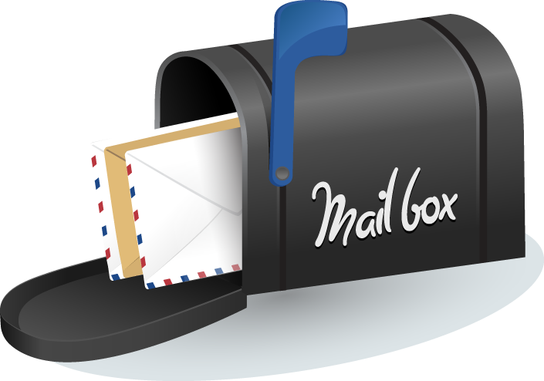

How to update your mailing address:

* Go here: <https://anpdh.nursingnetwork.com/>
* Click on *My Home* in the top corner
* Click on *Manage Account*
* Click on *Location Information*