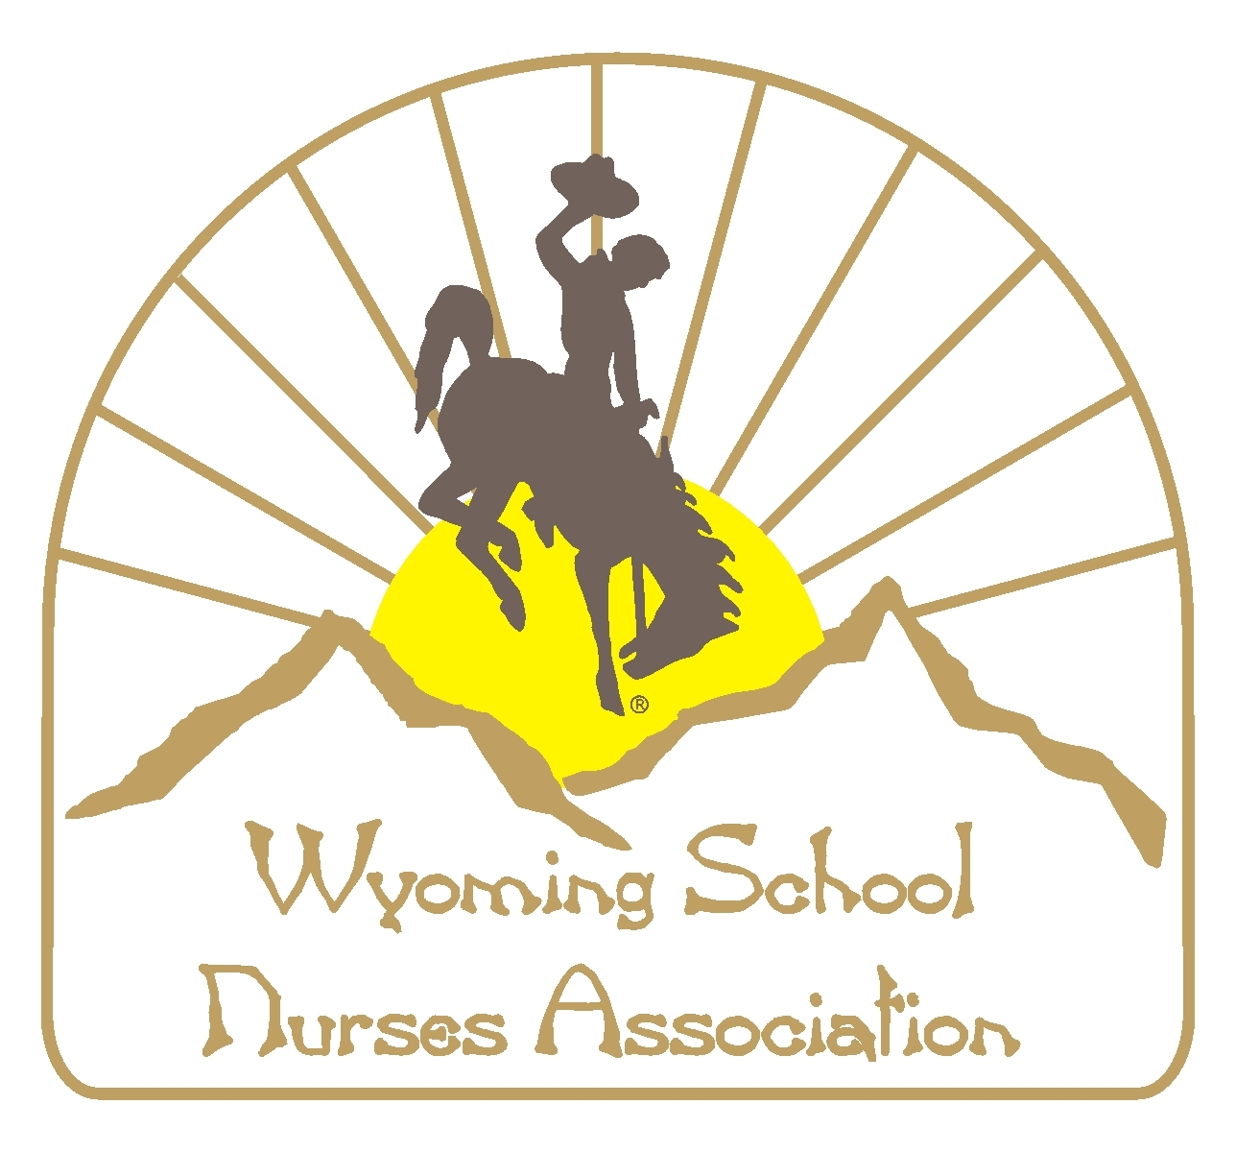

**wSNA LIAISON TO**

**nATIONAL BOARD OF CERTIFICATION FOR SCHOOL NURSES**

**ROLE OF THE STATE LIAISON**

State liaisons play an important role in supporting NCSN certification by:

1. Serving as a resource on certification.
2. Promoting certification.
3. Participating in state school nursing activities and sharing NCSN information.
4. Liaising with members of the NBCSN Board.