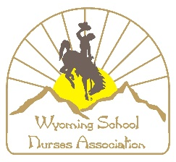

**AREA REPRESENTATIVES**

**Job Description**

**Objective:**

* To recruit new members and retain current members
* To assist in promoting the mission of Wyoming School Nurses Association (WSNA)
* Organize educational opportunities for Area constituents

**Membership Committee Composition:**

* WSNA members with an interest in promoting the benefits of membership and growing the organization
* Unless otherwise stated in the bylaws or operating policies and procedures committee members will select the committee chair

**Roles & Responsibilities:**

* Maintain active membership in WSNA/National Association of School Nurses (NASN) unified
* Attend all Membership committee meetings or provide a brief report for the Membership chair prior meetings and/or as requested
* Assist with information dissemination to area membership:
  + Identify issues/events that are most impactful to the area
  + Obtain feedback from the local membership
  + Forward feedback to Membership chair as needed
* Facilitate organizing WSNA supported area educational program, speaker, etc. (prepare statement of objectives, budget, and expected and actual outcomes)
* Prepare and submit a brief area report to Membership committee chair prior to the annual conference
* Encourage school nurses in the area to become members of WSNA
* Promote WSNA activities, educational, networking and outreach opportunities
* Encourage area attendance/participation at annual WSNA conference, regional meetings, etc.
* Coordinate/communicate duties with fellow Area Representative’s if position is shared
* Frequently monitor and participate in electronic communications: listserv, website, and WSNA social media platforms
* Perform other duties as may be required or assigned