Welcome to the official first newsletter for Pacific Crest Regional Chapter of AACN! What a year so far! We have scheduled and canceled so many events it is hard to keep track of what is actually happening. During this time of change and learning a “new normal” our critical care chapter wants to continue to show support to our amazing nurses in Southern Oregon/Northern California. Thank you for supporting our chapter and the board members who work tirelessly for you!

One of our goals this year is to let you get to know each of our board members. I had an amazing conversation with our PCRC Chapter President, Leslie Rogers. Leslie has been a nurse for almost 10 years. She started out as a brand new nurse in the critical care unit. While in critical care she quickly moved into a Primary Charge Nurse position. In addition to this she also was an Emergency Flight Nurse and worked in the PACU. After 6 years she transitioned to Nurse Educator. From there she moved into the role of Manager of Professional Development. Leslie has a Masters Degree in Organizational Leadership and Health Systems.
What is your first memory of pcrc?
“It was Julie and Debbie harassing me (gentle harassment) that I needed to be involved. I went to a meeting while on shift and became involved that day as the PCRC Bulletin Board Updater. That was 9 years ago!”
What made you join the chapter?
“After I got involved I wanted to soak up everything about critical care and that was a great avenue to do that and I’ve never grown out of that phase.”
What is your favorite type of patient to care for?
“This is going to make me sound like a bad person, but, - Vented with some sort of device in the room like a balloon pump. I enjoy connecting with my patients that are not sedated and vented, but the vented, complicated patients are like a difficult puzzle to solve.”
Do you have a least favorite patient – or a patient that you would rather not be assigned to?
“I am not a nurse to refuse taking care of any type of patients, but definitely one that is blatantly abusive to staff- it gets tiring by the end of the day. I don’t mind patients that are difficult when going through medical issues causing the behavior, like withdrawal, it’s the patients that are just mean all day. Oh, also trach patients, but only because I don’t like sputum.”
Do you have a nurse that you admire or look up to?
“So many nurses have helped shape me into the nurse I am today. The nurses that have influenced me have shown me to: 1) Be a go getter and an advocate, 2) Stay cool calm and collected, 3) Show compassion, and 4) Generally to be positive even in negative situations.”
What are your free time activities?
“Baking fancy gourmet cakes – I like it better when it’s not a request, but something I can be creative with. Hanging out with my husband. Taking naps.”
Where would be the perfect place for a nursing conference?
“Seattle, because there is so much to do there and it’s still in the Pacific Northwest so not too far to travel….or Italy! – After all of this Covid stuff is over.”
Do you have a favorite catch phrase or saying?
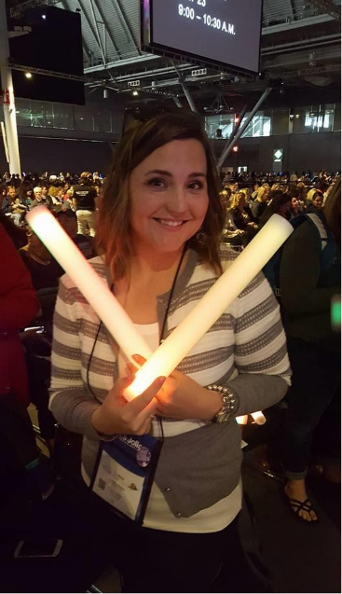
“Every time people need a reflection I offer this one –‘Even the greatest oak tree was once just a tiny little nut that stood it’s ground’ – “
What are your hidden talents?
“Cake decorating. I can sew well, basically I can do everything old lady like needle point, and knitting. I can also rap ‘Baby Got Back’, but you can’t make me do that easily.”
Do you have a message for our new chapter members?
“Recognize the value you bring. Healthcare is constantly adapting and we need to be constantly adapting with it.”
Thank you Leslie for your leadership and involvement in the PCRC chapter. If you are interested in more involvement with the chapter, please check out our website for the latest date and time of the next meeting: https://pcrcaacn.nursingnetwork.com
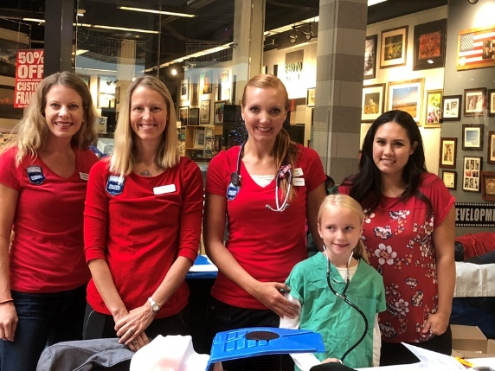
Recently I have thought about the value nurses bring to those around them. One thing I did not consider was how my career affected the view my family had on nursing. A couple of my colleagues with young kids were talking about how their kids play “hospital”. One of the kids was the house supervisor and another was a floor nurse. Another nurse said when her kids played hospital, one always had the clipboard and was the one to chart and the other was the one to “operate” on the patient. This was so intriguing to me. My version of a nurse as a kid was to change dressings and take vital signs.

It goes to show how the world and vision of nursing has changed, even amongst the young nurses in training. Fostering the growth and creativity of our young nurses is one of our chapter’s highest priorities. Stay tuned for our next education event. We are actively looking at ways our chapter can continue to provide continuing education while also abiding to restrictions on gatherings.

