Candidates for 2020 Ballot
President and ANA Membership Assembly Representative (1)
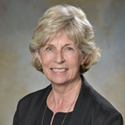
Marilyn Dollinger, DNS, FNP, RN
Finger Lakes Region
- Employment – Executive Associate Dean Wegmans School of Nursing St. John Fisher College
- ANA-NY Service
  - Legislation Committee Chair
  - Founding member
- Position Statement - As a founding ANA-NY member, I would be proud to serve as its President. I was appointed as the first chair of the ANA-NY Legislation Committee in 2013 and continue to serve as a consultant for that committee.
After 15 years in adult critical care, I spent 30 years in nursing higher education as an academic and administrative leader, active in regional and state professional nursing and community-based organizations. I will bring my leadership skills and experience in health policy and legislative advocacy to serve ANA-NY members as we transform our profession from “most trusted” to “most influential” in healthcare.
Treasurer (1)
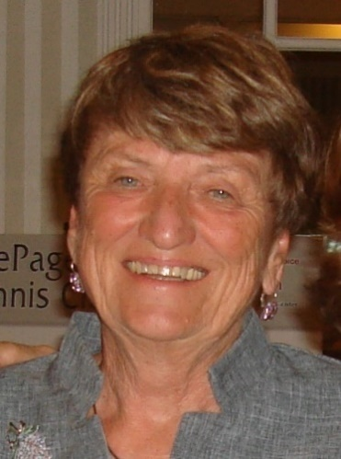
Linda O’Brien, MS, RN
Long Island Region
- Employment – Long Island Community Hospital Home Care Clinical Coordinator
- ANA-NY Service
  - Charter Member
  - Past member of Finance Committee and Annu8al Meeting Committee
  - Board of Directors
- Position Statement - I have always been a proud member of the nursing profession and recognize the value of membership in ANA-NY
I have great respect and appreciation for the determination and strength of my colleagues who continue, despite many obstacles, to provide high quality, knowledgeable and professional care to their patients. The Professional Nurse is truly an educated and ethical health care provider. If elected, I would be active participant in advocating for patients, promoting the profession and growing the association, so that ANA-NY will be recognized as foremost authority on professional nursing in NYS.


Phyllis Yezzo, DNP, RN, CPHQ
Lower Hudson Region
- Employment – SVP, Patient Care Service/CNO @ Bon Secours Charity Health System and Adjunct Professor @ Touro College
- ANA-NY Service
  - Director-at-Large
  - Nominating Committee
  - Audit Committee
- Position Statement - Nursing, as the most trusted profession, has a role in the health and well-being of the nation and has a responsibility to protect the public. In addition, Nursing has a key role to influence healthcare costs. Nurses need to have an understanding of healthcare costs and to be an advocate to provide quality care in a fiscally responsible manner. As such, nurses are a valuable asset to healthcare by providing direct patient care, and insight into cost-saving measures. Being responsible for the nursing budgets of a healthcare system, I can bring unique insight into the role of Treasure of ANA-NY.
Director-at-Large (2)

James Connolly, MSN, RN
Long Island Region
- Employment – St. Francis Hospital Emergency Room RN
- ANA-NY Service
  - Finance Committee
  - Legislation Committee
  - Membership Assembly Representative
- Position Statement - Nursing is a profession that is vital to the operation of healthcare. 2020 is the year of the Nurse. As such, nurses can continue to advocate for positive changes in healthcare policy decisions.
Nurses are vital to patient outcomes and population outcomes. Due to this, advancing the profession's involvement is vital to the populations we provide service to. Educating nurses on how to be more involved in organizations and policy decisions will allow a higher percentage of nurses to be heard.
Through increased individual, organizational, and governmental involvement nurses can push the profession forward and impact the lives of many.

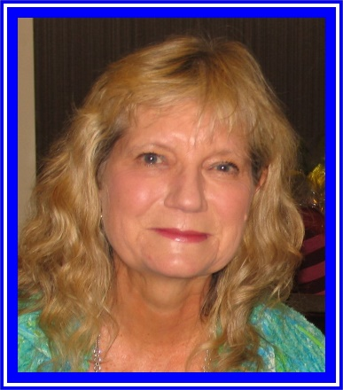
Susan Dewey-Hammer, MN, RN
Long Island Region
- Employment – retired
- ANA-NY Service
  - Charter member
  - Legislation Committee
- Position Statement - I have been an RN for 47 years. I obtained a BSN from the University of Minnesota and a MN from UCLA. In my extensive career, I have worked as a staff RN, supervisor, CNS, professor and I retired in 2016 as the College-Wide Nursing Coordinator for SCCC School of Nursing. I strongly believe that nurses need to be more involved in policy decisions and legislation. I think that nurses are the key to promoting the health of our local and global communities. Therefore, I am running for Director-At-Large to ensure ANA-NY's mission continues to be implemented.
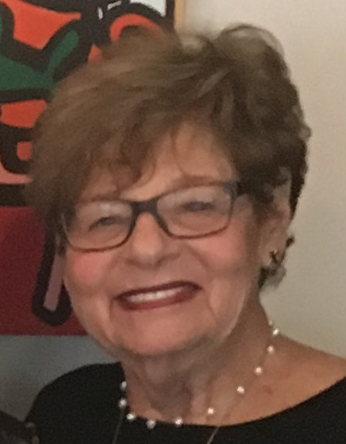
Marilyn Klainberg, EdD, RN
Long Island Region
- Employment – Faculty, Adelphi University College of Nursing and Public Health
- ANA-NY Service
  - Annual Meeting Committee
- Position Statement - I would like to become more involved in ANA-NY as a member of the board, as I believe ANA-NY plays an important role as a professional organization that provides support to nursing education. promotes the rights and best interests for nurses in the workplace, as well as improving health care’s service to the community.

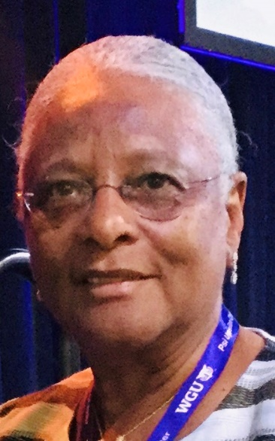
Sarah Marshall, DNP, MS, RNC, ICCE, CCE, CBC, CLC
Long Island Region
- Employment - SUNY Downstate Health Sciences University Patient/Community Health Educator and a Joint Appointment at the College of Nursing
- ANA-NY Service
- Position Statement - I am a proud and dedicated member of ANA-NY with diversified clinical nursing experience, knowledge, and expertise with various organizations settings. For instance, I am the current president of Alpha Omega Chapter, STTI, at Adelphi University and the Nurses for the Counties of Long Island (NACLI) Director-at-Large. Further, I am aware of nursing and healthcare issues and pledge to use my leadership abilities in collaboration with interprofessional and effective evidence-based practice to engage members in ANA goals. I will promote transparent communication, transformation of the healthcare system as indicated, mentor members and advocate to improve healthcare equality for all. These will lead to sustained membership retention and healthcare improvement on the Local, Regional, and National level.
Nominations and Elections Committee Member (3)

Grace Anne Crockett, BSN, RN
New York City Region
- Employment – Memorial Sloan Kettering Pediatrics Clinical Nurse I
- ANA-NY Service
  - New graduate
  - Vice President of Nursing Students Association of New York State (NSANYS)
- Position Statement - I believe I am a qualified candidate for the ANA-NY Nominations Committee for the 2020-2022 term due to my dedication to the nursing profession as a whole and my past experience serving on boards within various pre-professional organizations. From the beginning, I have chosen to focus on not only the educational and bedside parts of nursing, but also the professional involvement that shapes nurses into well rounded professionals committed to the evolution of practice which is ever changing. As a committee member I will promote advancement of nurses, including nursing students, new graduates and seasoned nurses improving health care overall.
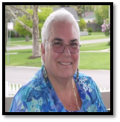
Elisa Mancuso, RNC-NIC, MS, FNS, AE-C
Long Island Region
- Employment – Retired Suffolk County Community College
- ANA-NY Service
  - President
  - Membership Assembly Representative
  - Director-at-Large
  - Education Committee
  - Annual Meeting Committee
  - Legislation Committee
- Position Statement - I have assisted with the development and growth of ANA-NY as a Director at Large and currently President. In these leadership positions I have cultivated relationships with numerous nurse colleagues across the state. As a member of the Nominations and Elections Committee I would reach out to members across the state who have demonstrated leadership skills and a desire to facilitate the expansion of ANA-NY with innovative approaches/programs. I believe it is inherent we seek diverse members; early career to seasoned professionals from eclectic venues to provide rich and fresh perspectives to insure ANA-NY flourishes as the professional nursing organization.
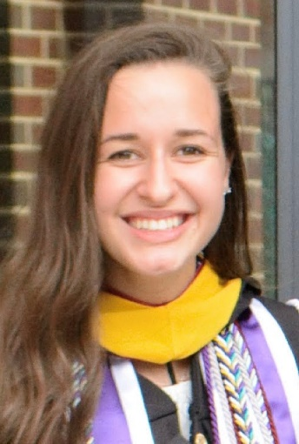
Megan Scali, BSN, RN
Lower Hudson Region
- Employment – NYU Langone Medical Center Staff Nurse
- ANA-NY Service
  - New graduate
  - Co-Vice President of Nursing Students Association of New York State (NSANYS)
- Position Statement - I would like to be considered for a position on the Nominations and Elections Committee of ANA-NY during the 2020-2022 term. The committee is important to ensure continued success of ANA-NY by holding loyalty to the bylaws to fairly present a qualified slate of candidates. As a new graduate with vast pre-professional leadership experience in New York State, I will be a connection for new, qualified nurses to become more involved with ANA-NY. Additionally, I will use my experience to make connections with members across other professional organizations to contribute to the success and diversity of the organization and election.

