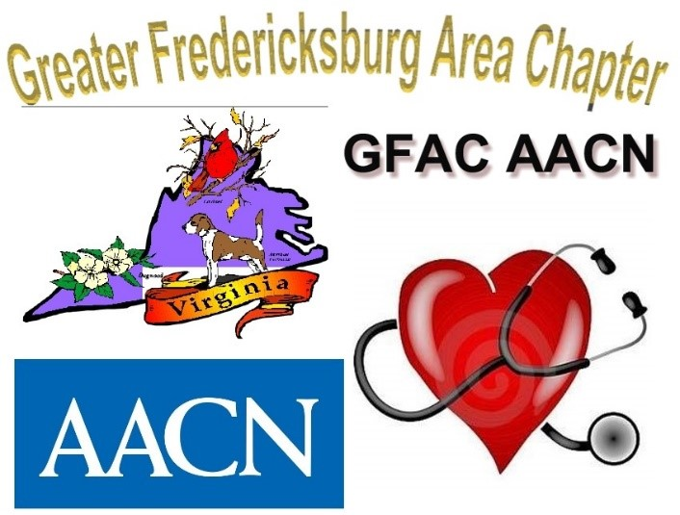

Greater Fredericksburg Area Chapter of AACN **provides a local forum to assist critical care nurses in meeting the challenges and demands of their profession and caring for the critically ill through networking**, **communication**, **education**, **and** **research**.

**Check out gfacaacn.nursingnetwork.com to get up to date information!**

***Upcoming events for the 2020-2021 year***

**August 17, 2020** Transition meeting for GFAC new Board of Directors @1800

**September 17, 2020** Board Meeting @1800 and ***Educational Meeting*** *1830-1930*

Fick Conference Center-MWH Campus, Auditorium 3

**September 29, 2020** Micah House Dinner @1730

**\*\*\*October 19, 2020** **GFAC Symposium** 1500-2030

Fick Conference Center – MWH Campus

**November 19, 2020** Board Meeting @1800 and ***Educational Meeting*** *1830-1930*

Fick Conference Center-MWH Campus, Auditorium 3

**December 29, 2020** Micah House Dinner @1730

**January 21, 2021** Board Meeting @1800 and ***Educational Meeting*** *1830-1930*

Fick Conference Center-MWH Campus, Auditorium 3

**\*\*\*March 18, 2021** **GFAC Certification Dinner** and ***Educational Meeting*** *1830*

Fick Conference Center – MWH Campus, Auditorium 3

**March 30, 2021** Micah House Dinner @1730

**May 24-27, 2021** NTI in San Diego

**June 29, 2021** Micah House Dinner @1730

***Sign-up in gfacaacn.nursingnetwork.com

The Chapter provides dinners to the Micah Ministries Respite House on every 5th Tuesday. If you would like to participate, please contact Laurie Reiss at [Laurie.Reiss@mwhc.com](mailto:Laurie.Reiss@mwhc.com)

Light snacks will be provided at each educational meeting