Vice President / President-Elect
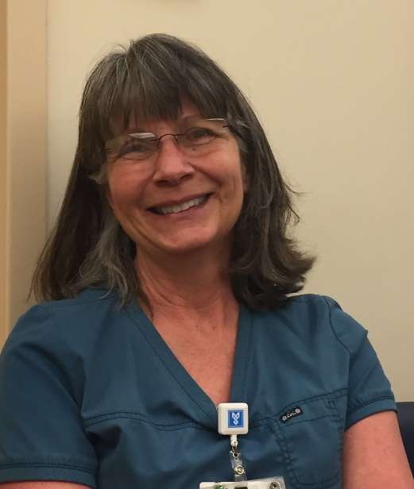
Mary E. Will, RN, BSN , CAPA

Employer & Role: Mid Coast Hospital, Brunswick, Maine, PAT Staff Nurse
Certification(s): CAPA Certified since 2014
Leadership Roles:
- Co-Chair ACU Professional Practice CommitteeHospital Wide Education Committee
- MESPAN & ASPAN Member since 2015
- MESPAN Board of Directors since 2015
- MESPAN Education Co-Director 2016
Personal Statement: When I’m not working or volunteering on the MESPAN Board of Directors, I love spending time with my 5 grandchildren. I truly love my children, but I adore my grandchildren! I have accomplished many things in my life including graduating from nursing school at age 52! As president of MESPAN, I will remain passionate about providing quality education for and serving Maine’s Peri-Anesthesia Nurses.

Treasurer
Mary Griffin, RN, BSN, MHA, NE-BC
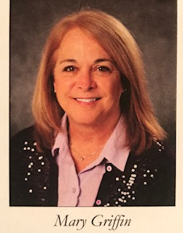

Employer & Role: MMC Scarborough Surgery Center, Scarborough, Maine; Nurse Director ASU, PACU, Short Stay
Certification(s): Nurse Executive, Board Certified
Leadership Roles:
- Committee Chair, MMC Periop Informatics
- Committee Member, Multiple MMC Nursing Care Quality & Safe Patient Care
- Sigma Theta Tau
- MESPAN & ASPAN Member
- MESPAN Board of Directors since 2017
- MESPAN Membership Communciation & Newsletter Editor
- Church Street Maximillian Kolbe
- Partners for World Health Volunteer
- Scarborough Softball Boosters
Personal Statement: I am a native Mainer, married 35 years to Tom Griffin, a middle school teacher, and I have three children: Michael a PA-C in MA, Kelsey a Second Grade Teacher in NC and Sean a PhD Student in WA.

·

Board Member at Large
Kandy Ivy, RN, BSN, CAPA, Level IV

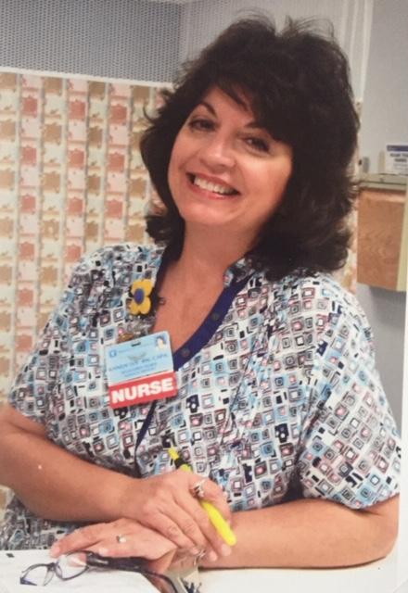

Employer & Role: Mid Coast Hospital, Brunswick, Maine; ACU, PACU, Cardiac Cath Prep & Recovery, Conscious Sedation for Endoscopic & Bronchocscopy Procedures, Infusion Therapy & PAT
Certification(s): CAPA
Leadership Roles:
- Resource Nurse
- PAT Lead
- MESPAN & ASPAN Member since 2009
- Ethics Committee
- Past Edcuation Committee Member
- Past Magnet Committee Member
- Certification Group Leader
- Red Cross Nurse with deployments to Texas after Hurricaines Katrina and Rita
- Project Hope
- Service on Navy Ship, Comfort with deployment to Haiti Earthquake Disaster
Personal Statement: I am originally from Arkansas but have lived in many places in the United States and Guam, Spain, and England. I currently reside in Harpswell (my home for the last 12 years). My daughter is an artist and lives in Los Angeles. In my leisure time, I find joy in being a bee keeper (this is my 7th year) but, my first love is music. I have been involved in several musical groups and bands since 2009 and perform locally.
I look forward to being involved with MESPAN if I am elected. I will do my best to support the board and promote our Nursing Specialty.
Board Member at Large
Carol Silsby, MSN, RN, CAPA
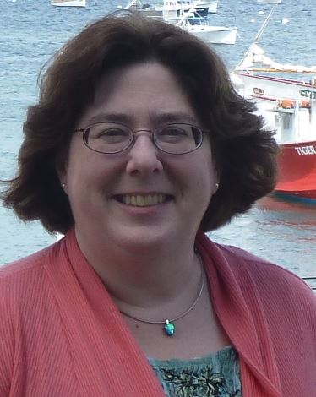

Employer & Role: Mid Coast and Blue Hill Hospitals; Director of Clinical Education NLH
Certification(s): CAPA
Leadership Roles:
- Serve on numerous hospital wide committees
- AHA Training Center Coordinator
- ACLS Faculty
- Past President MESPAN
- Past MESPAN Education Coordinator
Current or Former Awards:
- ASPAN Star Award: 2005, 2009
Professional Associations:
ASPAN/MESPAN
ANPD
Personal Statement: I have 38 years of nursing experience. I am married with 2 grown children.
While I have moved from Peri Anesthesia Nursing to Director of Clinical Education for two facilities, my passion remains with Peri Anesthesia Nursing. Peri Anesthesia Nurses work with patients at one of their most vulnerable times. It is with our knowledge and compassion that we help patients transition through their surgical experiences. I would Iove to become an active member of the board again so that I can help promote our organization and our nursing practice.

