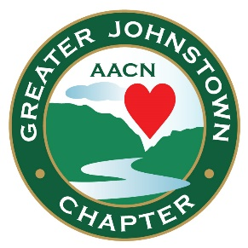

Announcing

The Greater Johnstown Chapter
of The American Association of Critical-Care Nurses (AACN)

Board of Directors

FY 20-21:

Sandy Dunn, President
Christina Schilling, President-elect
Heather Vitko, Immediate Past President
Sally Oldham, Treasurer
Kristin Bigam, Treasurer-Elect

Heather Vitko, Secretary, Membership & Engagement Chairperson
Charlene Trimeloni, Education Coordinator
Dawn Drahnak, Programming Chairperson
Darlene Dubay, Merit & Scholarship Chairperson
Sherry Morrison, Certification & Recognition Chairperson
Frances Watson, Nominating & Mentoring Chairperson
Christine Schreyer, Community Chairperson
Dawn Drahnak, Media Chairperson
Alison Alcantara, Wade Evans, Kimberly Gorman, and Stephanie Rhoades, Directors

