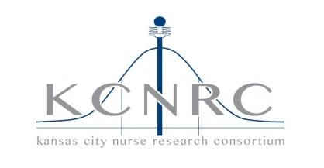

5/15/2020

7:30-9:00
Join Microsoft Teams Meeting
+1 816-301-7394
Conference ID: 593 701 588#
Join with a video conferencing device
853585975@t.plcm.vc
VTC Conference ID: 1162341369

Point of Contact:
Susan Teasley
816-550-8541

2019/2020 Officers:
Pat Conley, Chair (RMC)
Sue Teasley, Chair Elect (CMH)
Ashley Peacock, Secretary (NKCH)

2019-2020 Meetings:
08/21/2020 North Kansas City Hospital
10/16/2020 AdventHealth Shawnee Mission
Introductions and changes to agenda
Review of Prior Minutes 3/20/20
Email Vote:
approved –4; approved with revisions –0; abstained –2
Announcements – open to all
- Professional Development and other Educational Opportunities
- Clinical Trial/Research Studies
Old Business
- Collaborative Studies: Compassion Sat.
- KCNRC website - Lisa Guthrie’s
- 2020 KCNRC Symposium – All
    - Rescheduled 10/23/20
New Business
- Elections - New Chair Elect
- COVID – lessons learned
Presentation
- None at this time
Adjournment
Next meeting:
08/21/2020 North Kansas City Hospital

AGENDA

Kansas City Nursing Research Consortium
https://kcnrc.nursingnetwork.com/

