
Hello Beta Nu Members,

Don’t forget Beta Nu Business Meeting (via Zoom) tomorrow, Thursday, April 2nd at 5pm! Just click on this link a few minutes before 5pm (mute your video and audio to aide with internet speed): https://zoom.us/j/728670268 To call in the number is: 1-646-876-9923.
Please scroll down to review Beta Nu Research and Travel Grant Recipient’s written presentations!
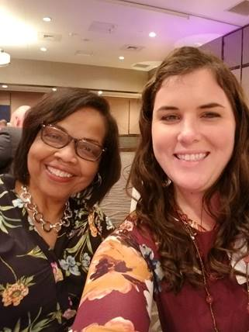
Liz Mizelle is pictured on the right with colleague Wendy Bridgers

Presentation by: Beta Nu Research Grant Recipient Liz Mizelle

Presentation Title: The Influence of Culture, Place and Climate Change on Hydration Status Among Latino Farmworkers

Purpose: The goal of this proposed study is to examine culture, place and climate change on hydration among farmworkers in eastern North Carolina (NC).
Significance: Heat-related illness is a disproportionate killer among farmworkers in NC. With increasing outdoor temperatures, drinking water to control heat stress is critical. Farmworkers report various barriers to consuming water while working, including beverage preferences and occupational norms, suggesting further exploration of these variables is necessary.
Methods: The proposed study design is mixed method, participatory action research (PAR) involving a pre-established partnership with community outreach workers at a Federally Qualified Health Center (FQHC). Phase 1 of the study will involve focus group discussions among 24 to 60 farmworkers. Inductive content analysis will be employed to find patterns and commonalities among the data during this phase. Phase 2 will include a demographic survey, clinical biomarkers of hydration, beverage intake assessment questionnaire, and wet bulb global temperature. Fourth to sixty participants will be included and descriptive statistics and logistic regression models will be utilized to analyze the quantitative data.
Nursing Implications: This study aims to improve specific heat illness prevention measures for farmworkers in the changing climate of NC, including development and enaction of a federal or North Carolina state occupational safety and health regulations that specifically address heat illness.

Presentation by: Beta Nu Research Grant Recipeint Mitzi Pestaner
Presentation Title: School Connectivity and Help-Seeking Behavior Among an At-Risk 6^{th-}Grade Middle School Population: Collaborative Opportunities for School Nurses

Introduction: School connectivity has been found to be a protective factor against suicidal thoughts and behaviors (Centers for Disease Control and Prevention [CDC], 2018; Marraccini & Brier, 2017; Resnick et al., 1997). Connections to adults in schools may increase the opportunities for adolescents to seek help in times of distress, including for suicidal concerns (Whitlock et al., 2014). Since suicide is the second leading cause of death for children ages 10-14 (CDC, 2019) and suicide attempts are highest during the mid-adolescent years (Carballo et al., 2019), school connectivity is important for the adolescent population. Of significant concern is the increase in suicide rates among African American adolescents with rates increasing by 60% for males and 182% for females from 2001 – 2017 (Price & Khubchandani, 2019). There is a gap in knowledge on how or from whom high-risk groups, such as racial/ethnic minorities and younger adolescents in middle school, seek help during times of stress (De Luca et al., 2019).
School nurses are often the first health care provider to see at-risk adolescents (Bains & Diallo, 2016) and in a key position to facilitate connectedness between teachers, support staff, and students to prevent suicide (Kim et al., 2019). Yet, in an integrative review conducted by Pestaner et al. (2019), evidence of school nurse collaboration with other school staff in suicide prevention was minimal. To address the issue of adolescent suicide, the proposed research will focus on the school environment and the way middle school students, particularly minorities, connect with others within that environment, including the school nurse, teachers, and other support staff, as one determinant of whether they engage in help-seeking behavior when distressed.
Approach: This study will be conducted at a Title 1 public, rural middle school with significantly higher in-school suspension, absenteeism, and bullying rates as compared to the state average and comprised of a low-income population with 60% of enrolled students being African American (NC Department of Public Instruction, 2019). Participants will be comprised of a convenience sample based on community partnered research with an established partner. Recruitment will take place at open house and parent/teacher conferences during August - September 2020.
A sequential, explanatory mixed-methods design (Chiang-Hanisko, Newman, Dyess, Piyakong, & Liehr, 2016), in which quantitative and qualitative techniques are combined will guide the study consisting of two phases. In Phase I, the prevalence of school connectivity and help-seeking behaviors will be measured with pen and paper surveys during the last week of September 2020. In Phase II, student focus groups will be conducted in October 2020 to further explain and interpret the quantitative data by exploring student perceptions of school connectivity and help-seeking behavior.
Summary: The long-term goal of this research is to develop suicide prevention strategies by identifying collaborative opportunities between school nurses, teachers, and support staff to enhance help-seeking behavior among an at-risk middle school population. School connectivity and help-seeking are intimately related to decreasing suicide risk and it is important to understand the relationship between these concepts when developing effective suicide prevention strategies.
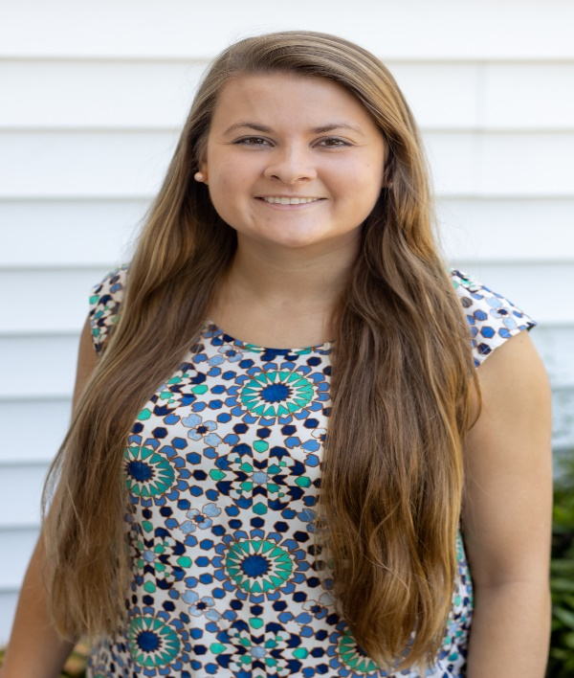

Presentation by: Beta Nu Travel Grant Recipient Morgan Braxton
Research Plans for Grant Money: The Beta Nu International Professional Development Grant will cover my professional development, through language coursework in August 2020 in Guatemala, under the supervision of Dr. Kim Larson. In order to be adequately prepared for my dissertation research, I have identified the need for further language development, cultural immersion, and the opportunity to build rapport and trust with the organization I plan to partner with, a nutrition treatment center in Guatemala. To do this, I plan to go for two weeks, to study language and volunteer at the nutrition treatment center. Funding from this grant will offset travel costs, as well as provide a donation to the nutrition rehabilitation center. This will be invaluable experience and will be a building block for further dissertation work.
My mission is to improve the health and wellbeing of Guatemalan children. This opportunity to develop as a global nurse scientist through volunteering and language development is an excellent opportunity to better understand health and illness in Guatemala and build a program of research on this long-term relationship. The Beta Nu International Professional Development Grant will allow me to advance the science about nursing contribution to child growth and development in a nutrition rehabilitation center and to make a difference in global health.
I am so thankful to have Beta Nu’s support in this grant and look forward to sharing my experience when I return. I am still hopeful to be able to travel in August but will adjust travel plans if needed pending progression of the virus. I appreciate Beta Nu’s aligned passion for global health, and I hope to use my career to enable positive change in children’s health worldwide.

Beta Nu applauds and congratulates all our presenters! Thank you for your hard work to improve the health of those we care for!

Melissa Beck
Sigma, Beta Nu Chapter President

